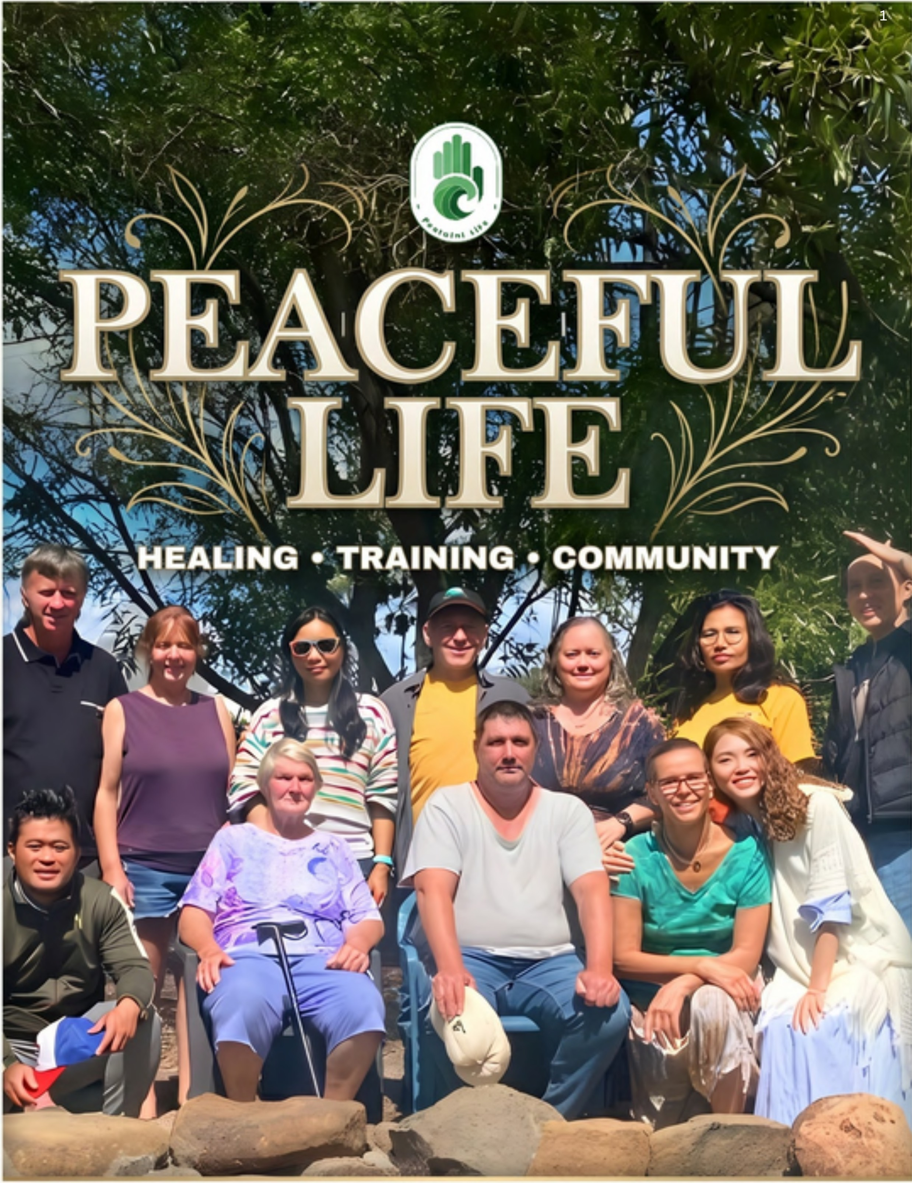

EMPOWERING HOLISTIC WELL-BEING THROUGH
KNOWLEDGE, CONNECTION, AND NATURAL HEALING

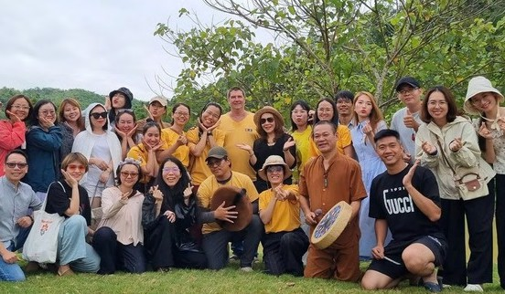


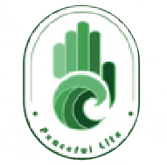
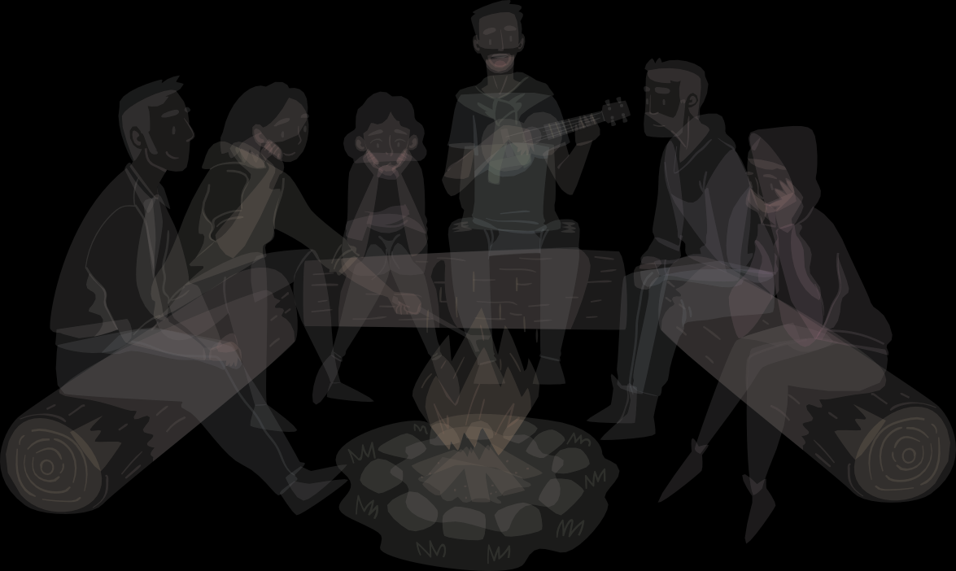
A community built on
2
ABOUT PEACEFUL LIFE

co-creation
Peaceful Life is a member - collaborative organization built on the principle of co-creation. Each therapist works as an independent practitioner while joining together to carry out projects—whether small or large—that promote community well-being. Everyone is rewarded based on their contributions, ensuring that our work grows from fairness, shared effort and mutual respect.

Courses List

S No | Courses
1 | Siam Reiki Level 1
2 | Siam Reiki Level 2
3 | Siam Reiki Level 3 (Master)
4 | Developing Psychic Awareness
5 | Crystal Healing
6 | Pendulum Diagnosis
7 | Transcending
8 | Aura Reading
9 | Psychometry
10 | Energy Protection
11 | Single Bowl
12 | Singing Bowl Level 1
13 | Singing Bowl Level 2
14 | Card Reading Level 1
15 | ART Hello Again

Courses List

S No | Courses
16 | Guide Drawing
17 | Circle Workshops
18 | Hawaiian Massage
19 | Relaxing Massage
20 | Nurturing Massage
21 | Slimming Massage
22 | Ayurveda
23 | Spine Yoga
24 | Normal Yoga
25 | I Ching Level 1
26 | I Ching Level 2
27 | Feng Shui
28 | Self-Defence
29 | Hormone Yoga
30 | Pranayama

Courses List & More

S No | Courses
31 | Qigong
32 | Faceology
33 | Horoscope — Level 1
34 | Recognition of Prior Learning
35 | MEMBERSHIP PROGRAMS
36 | FIRE GATHERING
37 | IN-DEPTH SPIRITUAL RESEARCH & DISCOVERY TOUR
38 | DESTINY DAY
39 | SILENT RETREAT
40 | REIKI SHARE
41 | PEACEFUL LIFE CHARITIES

Services List

S No | Online Service Name
1 | Distant Reiki with Siam Reiki Level 3 (Master)
2 | Distant Reiki with Siam Reiki Level 5
3 | Pendulum Diagnosis
4 | Explore Your Extrasensory Perception
5 | Aura Reading with Siam Reiki Level 2 Practitioner 30 Mins
6 | Aura Reading with Siam Reiki Level 3 Practitioner 30 Mins
7 | Card Reading with Siam Reiki Level 2 Practitioner 30 Mins
8 | Card Reading with Siam Reiki Level 2 Practitioner 60 Mins
9 | Card Reading with Siam Reiki Level 3 Practitioner 30 Mins
10 | Card Reading with Siam Reiki Level 3 Practitioner 60 Mins
11 | Soul-Level Card Reading 60 Mins
12 | Soul-Plan Card Reading 120 Mins
13 | One-on-One Counselling with Winnie
14 | I Ching Reading Consultation
15 | Consultation from Esoteric Disciplines

Services List

S No | Online Service Name
16 | One-on-One Personal Yoga with Teacher Ngoc Diep
17 | Draw Guide (PL student)
18 | Draw Guide (not PL student)
19 | Draw Guide — Consultation for non-PL student clients
20 | Draw Guide (not PL student) — Global
In Person Service Name
21 | 3D — NLS Scan
22 | EWS Scan — Vitamin and Mineral Deficiency
23 | Meta-Therapy — Pain and illness relief support using meta waves
24 | Reiki Share
25 | Hands-on Reiki with Siam Reiki Level 3 (Master)
26 | Hands-on Reiki with Siam Reiki Level 5
27 | Hands-on Reiki with Siam Reiki Level 9 (Master Steve)
28 | One-on-One Singing Bowl
29 | Group Sound Bath

Services List

S No | In Person Service Name
30 | Land and House Cleansing Service
31 | VIP Health Program
32 | Acupressure Therapy
33 | Slimming Massage
34 | Nurturing Massage
35 | Full-Body Relaxing Massage
36 | Abdominal Wellness Massage - 5 Sessions
37 | Abdominal Wellness Massage - 10 Sessions
38 | Abdominal Circumference Reduction 10-15 Sessions
39 | Neck & Shoulder Massage (HNS) 30 Mins
40 | Neck & Shoulder Massage (HNS) 60 Mins
41 | Foot Reflexology Massage




Siam Reiki Level 1
9
ONLINE SERVICES
The Foundation of The Siam Reiki

DURATION
2 days (1 day theory + 1 day hands-on) + 4 Attunements
PREREQUISITE
Age 13+; not for pregnancy under 3 months
Students receive 4 energetic Attunements that open a safe, direct channel to universal healing energy, and learn the standard hands-on protocol used throughout every level above.

WHAT YOU'LL GAIN
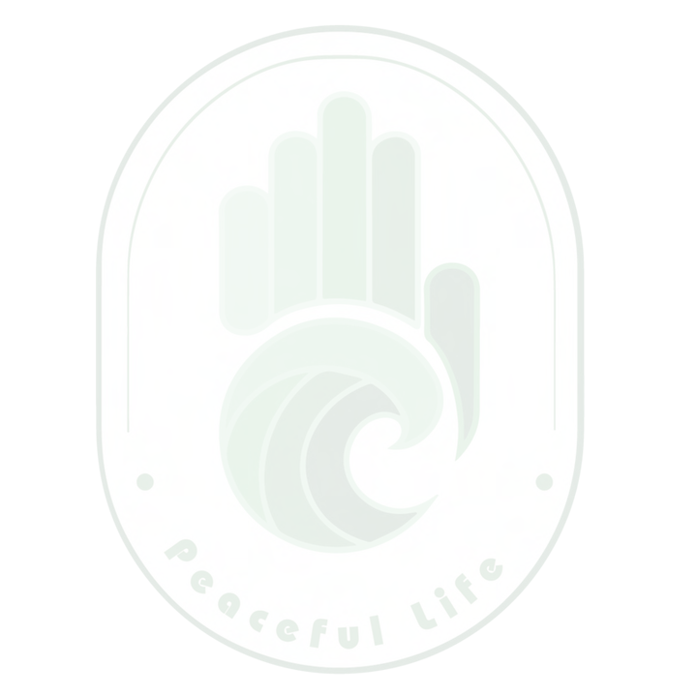
Understand the science of energy and the chakra system Four Attunements connecting you directly to your Guides A complete, standardised hands-on treatment protocol Self-soothe pain, calm the nervous system, sleep deeper
Safe boundary-setting so you can support others without draining yourself

WHO IT'S FOR
Complete beginners to energy work
Anyone seeking natural relief from fatigue, poor sleep, or stress Parents and caregivers wanting a gentle healing tool for family Sensitive people who tire easily around others

WHAT MAKES IT DIFFERENT
You are never the source of the energy — only the channel — so giving Reiki heals you as much as the person receiving it. Four Attunements delivered directly by the instructor keep the lineage authentic and safe.

Siam Reiki Level 2
10
4 Body Practice & Distance Healing

DURATION
2 Days
PREREQUISITE
18+; Level 1 completed 2+ months, min. 10 hands-on sessions; not for pregnant women
Expands your practice across all four bodies — physical, emotional, mental, spiritual — and introduces three original Reiki symbols that unlock remote (distance) healing and space-clearing.
WHAT YOU'LL GAIN
Work across the physical, emotional, mental & spiritual bodies Practise Reiki remotely, with no geographic limits
Use symbols to clear and protect living spaces
Two supporting meditations for grounding and purification
WHO IT'S FOR
Siam Reiki Level 1 graduates ready to deepen their practice Practitioners wanting to support loved ones remotely
WHAT MAKES IT DIFFERENT
The symbol system taught here is the gateway to every advanced Siam Reiki application that follows — remote healing, space clearing, and beyond.

Siam Reiki Level 3 (Master)
Become a professional Reiki therapist

DURATION
2 days
PREREQUISITE
18+; Level 2 completed 6+ months; 30 client sessions; Crystal, Pendulum, DPA & Transcending completed; 30 logged health reports; Interview with Master Steve

The Reiki Master level. Graduates may charge for therapy sessions and receive the deepest lineage teaching — the history of Reiki from Mikao Usui through Hawayo Takata — plus how to establish the Master symbol in spaces, objects, and treatment rooms.
WHAT YOU'LL GAIN
Certified to charge for professional Reiki sessions Full lineage history and symbolism training Advanced space and object Reiki set-up
Ongoing mentorship inside the Siam Reiki Master community
WHO IT'S FOR
Level 2 practitioners ready to become professional therapists
WHAT MAKES IT DIFFERENT
A strict, interview-gated entry protects the integrity and lineage of the Original Reiki energy — nothing added, altered, or blended with other systems.

- Developing Psychic Awareness A 30-Meditation Journey Into Safe Intuition
12

DURATION
7 days
PREREQUISITE
Siam Reiki Level 1 completed
A deep, 30-meditation programme that develops psychic perception as a trainable skill — building safe Guide connections, clear energetic boundaries, and the ability to trace blockages to their root cause.

WHAT YOU'LL GAIN
- 30 guided meditations for opening psychic senses
- Safe, structured communication with higher-level Guides
- Boundary-setting to prevent energetic burnout
- Deep inner healing alongside skill development
WHO IT'S FOR
- Siam Reiki Level 1 graduates ready to grow their intuition
- Future healers, therapists, and coaches

WHAT MAKES IT DIFFERENT
Combines psychic development with genuine inner healing — you clear your own blocks before learning to help others with theirs.

Crystal HEALING
13
From Guesswork to Systematic Crystal Practice

DURATION
2 days
PREREQUISITE
Siam Reiki Level 1 completed
Moves students from choosing crystals "by feel" to understanding, cleansing, charging, and applying them safely and systematically — alone or alongside Reiki and meditation.

WHAT YOU'LL GAIN
- Choose the right crystal with confidence
- Cleanse, charge, and store crystals correctly
- Apply crystals for emotional balance, sleep, and space protection
- Combine crystals with Reiki and meditation practice
WHO IT'S FOR
- Beginners with no prior crystal experience
- Therapists, healers, and coaches wanting an additional tool

WHAT MAKES IT DIFFERENT
Learning through direct sensory practice, rather than memorised lists of "which crystal does what.”

Pendulum Diagnosis
14
A Verifiable Tool for Intuition and Diagnosis

DURATION
2 days
PREREQUISITE
Siam Reiki Level 2 completed
Turns the dowsing pendulum into a reliable, logical tool for verifying intuition, communicating with Guides, and pinpointing the root cause of energetic blockages during a session.

WHAT YOU'LL GAIN
- Set up a clear connection with your Guides via pendulum
- Ask precise questions that yield clear answers
- Cross-check intuition against pendulum responses for accuracy
- A repeatable process for locating root-cause blockages
WHO IT'S FOR
- Siam Reiki practitioners wanting a verifiable intuition tool

WHAT MAKES IT DIFFERENT
Combines intuitive sensing with a concrete verification process — a full information-retrieval protocol, not just "how to swing a pendulum."

Transcending
15
Reading and Safely Working with Complex Energy

DURATION
3 days
PREREQUISITE
Siam Reiki Level 2 & DPA completed
Bridges the gap between foundational Reiki and Master-level work by teaching practitioners to recognise, evaluate, and safely process the more complex, low-vibration energies encountered in advanced sessions.

WHAT YOU'LL GAIN
  - Identify low or "noisy" energy versus ordinary emotional responses
  - Set up and hold a protective personal energy field
  - A structured protocol for supporting energetic release
  - Greater calm and confidence in complex sessions
WHO IT'S FOR
  - Reiki practitioners preparing for Reiki Master
  - Anyone regularly drained after supporting others energetically

WHAT MAKES IT DIFFERENT
A required, safety-focused stepping stone before Reiki Master, not offered anywhere else in the standard curriculum.

Aura Reading
16
Seeing and interpreting the human energy field

DURATION
2 days
PREREQUISITE
DPA & Siam Reiki Level 2 completed
Trains students to see and interpret the human energy field and its layers, connecting what they observe to the seven-chakra system for a fuller diagnostic picture.

WHAT YOU'LL GAIN
- Understand aura structure and its link to the 7 chakras
- Observe and identify your own and others' energy fields
- Locate areas of imbalance or blockage
- Techniques to cleanse and stabilise the aura
WHO IT'S FOR
- Reiki practitioners wanting an added diagnostic tool
- Those deepening body-mind-spirit awareness

WHAT MAKES IT DIFFERENT
Hands-on aura-reading practice under live supervision, not just theory about the layers.

Psychometry
17
ONLINE SERVICES
Awakening Subconscious Intuition Through Touch

DURATION
8 Online Evening Sessions - 2 Hrs Each
PREREQUISITE
Siam Reiki Level 2 & DPA completed

Psychometry is the trainable skill of reading energy held in objects, photos, and personal items — proof that psychic sensing isn't a rare gift but a skill anyone can build. Guided directly by Master Steve, students learn to quiet self- doubt and follow a clear, logical framework for retrieving information through touch.
WHAT YOU'LL GAIN
Read energy held in objects, photos, and personal items
Trace missing pets, items, and even people through psychometric reading Apply the skill inside therapy sessions and daily life
Faster, sharper intuitive information retrieval

WHO IT'S FOR
Siam Reiki Level 2 & DPA graduates
Those wanting a structured, logical approach to intuition Anyone deepening their energy-sensing skills

WHAT MAKES IT DIFFERENT
An exclusive Siam Reiki methodology grounded in energy science, practised on real search cases inside a fully protected energetic space under Master Steve's direct guidance.

Energy Protection
18
Learn to Shield, Cleanse, and Reclaim Your Energy

The Energy Protection & Management course with Master Steve will give you proven tools to become the master of your own flow.
WHAT WILL YOU LEARN IN THIS COURSE?

We don't just talk about theory — we learn how to take action to protect body, mind, and spirit:

The Art of Aura Cleansing: Unlock advanced techniques for cleansing your personal energy field every day.
Building Your Protective "Armor": How to construct a powerful energetic shield for yourself and your living/working space.
Meditation & Intuition: Go deep into consciousness, mastering the power of visualization to navigate your inner energy flow.
Understanding the Chakra System: Connect deeply with your energy centers and emotional body layer.
Releasing "Energy Anchors": Identify and release the invisible influences holding back your growth.
Building Solid Inner Strength: Transform from a state of vulnerable sensitivity into a state of empowered sensitivity.
Special features of the "Energy Recovery and Protection" course
Each student will receive a set of energy protection items as a gift from Siam Reiki.
The course is conducted online, so you can join from anywhere in the world. The course is useful for everyone — whether you've studied Reiki before or not, you're welcome to join.
Master Steve will provide answers and guidance on energy protection tailored to each individual student, so class size will be limited to ensure quality.
The course teaches a variety of techniques for protecting and restoring energy that are effective, practical, and achievable for anyone.

Single Bowl
19
Personal Singing Bowl for Everyday Calm

DURATION
1 Day
PREREQUISITE
None
A gentle, no-experience-needed introduction to self-care using one singing bowl
— a simple tool for instant stress relief and a daily grounding ritual.

WHAT YOU'LL GAIN
- Play and rotate the bowl to create deep relaxation
- Clear the energy of a room or your own mind
- Combine bowl sound with meditation
- A trained "energetic ear" for choosing a genuine, well-made bowl
WHO IT'S FOR
- Complete beginners, even those who've never touched an instrument
- Busy, stressed people wanting a portable self-care tool

WHAT MAKES IT DIFFERENT
Needs only a single bowl — the simplest, lowest-cost entry point into sound healing.

Singing Bowl Level 1
20
Turning Sound into a Professional Wellness tool

DURATION
2 days
PREREQUISITE
None
This course turns sound into a professional wellness tool — using 4–5 bowls to run a full one-hour relaxation session for clients or yourself.

WHAT YOU'LL GAIN
- History and science of Tibetan singing bowls
- Run a complete 1-hour sound-relaxation session
- Identify blockages via sound and the Chakra System
- How to select genuinely high-quality bowls
WHO IT'S FOR
- Anyone adding sound therapy to a spa/wellness offering
- Complete beginners welcome

WHAT MAKES IT DIFFERENT
Global Sound-Healing Experience

Singing Bowl Level 2
21
From personal sessions to leading a group Soundbath

DURATION
2 days
PREREQUISITE
Singing Bowl Level 1 completed
The step from one-on-one sessions to leading a full group Soundbath — coordinating 14+ bowls while reading the body's condition through sound and intuition

WHAT YOU'LL GAIN
- Coordinate many bowls into one harmonious session
- Design and lead a group Soundbath
- Combine sound with intuitive body-scanning
- Curated short practices from renowned global bowl methods
WHO IT'S FOR
- Singing Bowl Level 1 graduates wanting to lead groups
- Spa & wellness professionals

WHAT MAKES IT DIFFERENT
The only level that moves from individual service into designing and facilitating group experiences.

Card Reading Level 1
22
Connecting Intuition and Symbolism

DURATION
2 days
PREREQUISITE
None
An intuition-first introduction to card reading — you'll learn the meaning behind imagery, colour, and symbolism, and how to trust your own sense over rote memorisation of guidebooks.

WHAT YOU'LL GAIN
- Read any deck without memorising individual card meanings
- Prepare energy, cards, and space before a reading
- Read for career, relationships, health & personal direction
- Remote readings for people or places
WHO IT'S FOR
- Complete beginners to card reading
- Anyone wanting to strengthen intuition through symbols

WHAT MAKES IT DIFFERENT
Intuition is the centre piece, not the guidebook — heavy group practice builds real confidence fast.

ART Hello Again
23
Still You, but A New Version

DURATION
7 sessions
PREREQUISITE
None (ages 6+)
A self-discovery journey through pencil, watercolour, and acrylic — combining Art Coaching, Art Psychotherapy, and Spiritual Channeling to release stuck emotion and reconnect with yourself.

WHAT YOU'LL GAIN
- Release stuck emotion through guided art-making
- Techniques across pencil, watercolour & acrylic
- Work through a different personal theme each session
- A renewed, lighter sense of self
WHO IT'S FOR
- Ages 6+
- Anyone wanting an emotional-release practice
- Those seeking stress relief without talk therapy
WHAT MAKES IT DIFFERENT
Blends art therapy, coaching, and spiritual channeling into one proprietary method — no prior art skill required.

Guide Drawing
24
Painting a portrait of your Spiritual Guide

DURATION
6 sessions (2 theory + 4 painting)
PREREQUISITE
Siam Reiki Level 2 & DPA completed
Connects students with their own Spiritual Guides — who they are, where they come from, and their purpose — then teaches acrylic painting technique to render their portrait.

WHAT YOU'LL GAIN
- Meditative connection and communication with your Guides
- Distinguish authentic Guides from false or "grey" energies
- Foundational acrylic painting & colour theory
- 10 take-home practice pieces
WHO IT'S FOR
- Siam Reiki Level 2 & DPA graduates wanting a creative extension

WHAT MAKES IT DIFFERENT
Taught exclusively by Master Qiti (Mỹ Thanh) at Peaceful Life retreats — a one-of-a-kind proprietary curriculum blending spirit-work and painting.

Circle Workshops
25
A four-circle journey of sound, connection & self-discovery

Inspired by Native American community traditions, Music Circle is a facilitated four-part journey — singing, movement, the Talking Circle, and ritual practice — designed to help you reconnect with yourself, your community, your roots, and your creativity. Each circle builds on the last, though the journey is circular, not linear: graduates are always welcome to return, repeat, or become a Supporter for newcomers.

Circle Theme Focus

Wolf Bear Buffalo Eagle
Courage to be yourself Power of harmony
Power of stillness Soaring with creativity
Self-connection, voice, emotional expression Belonging without losing yourself
Gratitude, ancestry, inner listening

Free creative expression, connection with nature


GOOD TO KNOW
Not a singing class or performance — a guided experiential practice where sound and presence become tools for connection. Bring a personal water bottle and loose, comfortable clothing. If in active psychological treatment or with mobility needs, please contact Peaceful Life in advance.

Hawaiian Massage
26
Traditional Lomi Lomi

DURATION
4 days
PREREQUISITE
Siam Reiki Level 1 completed
A traditional Hawaiian Lomi Lomi certification taught by Dan & Annette Sykes (22+ years' clinical experience), combining flowing, wave-like strokes with organic coconut oil and Annette's Reiki Master energy awareness.

WHAT YOU'LL GAIN
- A complete 90-minute Lomi Lomi treatment (give & receive)
- Lymphatic and circulatory stimulation techniques
- Emotional & energetic release methods
- Career-ready skill for spas and wellness centres
WHO IT'S FOR
- Massage therapists wanting a holistic modality
- Those drawn to energy-based bodywork

WHAT MAKES IT DIFFERENT
Taught by internationally credentialed instructors who trained directly in Hawaii, immersed in the island's original healing traditions.

11

Relaxing Massage
27
Full-body relaxation, career-ready skill

DURATION
4 days
PREREQUISITE
None
A practical, career-focused course in full-body relaxation massage — technique, pressure control, session flow, safety, and client experience.

WHAT YOU'LL GAIN
- A complete basic relaxation massage treatment
- Session-flow and safety protocols
- Work-ready for spas, wellness centres & retreats
- Foundation to combine with yoga, therapy, or coaching
WHO IT'S FOR
- Those entering the massage/wellness profession
- Those wanting an at-home or personal-business skill

WHAT MAKES IT DIFFERENT
Built for real market demand — a practical entry point into a growing wellness-industry career.

Nurturing Massage
28
Abdominal Wellness Massage

DURATION
Multiple Variants
PREREQUISITE
None
A hands-on abdominal wellness technique grounded in Traditional Eastern Medicine and modern anatomy — supporting digestion, qi and blood flow, and gentle abdominal-fat reduction.

WHAT YOU'LL GAIN
- Full professional abdominal-massage sequence
- Relief for cold abdomen, bloating & constipation
- Client assessment & treatment planning
- Immediately applicable to self, family, or spa clients
WHO IT'S FOR
- Those training for therapy work or a spa
- Postpartum women
- Those wanting to go deeper than basic massage
WHAT MAKES IT DIFFERENT
Merges Traditional Eastern Medicine meridian theory with anatomical precision
— traditional and clinically grounded at once.

Slimming Massage
29
Egyptian-method abdominal slimming, advanced

DURATION
Multiple Variants
PREREQUISITE
None
An in-depth certification in the Egyptian-origin abdominal slimming method, combining Traditional Eastern Medicine, modern anatomy, and a proprietary 6-step protocol using heat-inducing oils and herbal wraps.

WHAT YOU'LL GAIN
- Fat biology, lymphatic drainage & hormonal fat storage
- Full anatomy of the abdominal wall & organs
- The 6-step signature protocol, point-pressing to herbal wrap
- Client consultation & home-care guidance
WHO IT'S FOR
- Therapists wanting an advanced, results-driven specialty
- Spa owners building a signature service

WHAT MAKES IT DIFFERENT
A rare, technically deep curriculum spanning biology, TEM meridian theory, and a proprietary step-by-step method not taught elsewhere.

Ayurveda
30
The secret to a long, healthy life from ancient India

DURATION
Contact PL for current schedule
PREREQUISITE
None
A 5,000-year-old Indian system for understanding your unique constitution (dosha) and living in harmony with it — through diet, detox, sleep, and daily rhythm.

WHAT YOU'LL GAIN
- Identify your Vata, Pitta, or Kapha constitution
- Natural detox methods
- Dosha-matched diet & digestion support
- Emotional balance & natural sleep improvement
WHO IT'S FOR
- Anyone wanting a holistic, root-cause approach to health
- Those curious about ancient Indian wellness systems

WHAT MAKES IT DIFFERENT
Whole-life application — diet, sleep, emotion, and daily rhythm together, not an isolated technique.

Spine Yoga
31
A personalised approach to spinal health

DURATION
Contact PL for Schedule
PREREQUISITE
None
A structured path to mastering the breath as the body's natural regulator — countering shallow, rapid breathing that undermines emotional control, digestion, and stamina.

WHAT YOU'LL GAIN
- The physiological effect of each breath technique
- When to use which technique for your constitution
- Breathwork for anxiety and emotional regulation
- Techniques to expand lung capacity & circulation
WHO IT'S FOR
- Anyone feeling breathless under stress or fatigued easily
- Those wanting better sleep and focus

WHAT MAKES IT DIFFERENT
Breath is taught as a precise, technique-specific tool matched to constitution and situation, not one generic exercise.

Normal Yoga
32
Breath to Flow

DURATION
8 Sessions
PREREQUISITE
None (ages 6+)
Journey from breath awareness to full-body flow — building strength, flexibility, and grounded presence one theme at a time.

WHAT YOU'LL GAIN
- Diaphragmatic & cleansing breathwork
- Spine mobility, core strength & hip opening
- A connected, flowing sequence by week 7
- Restorative practice to close the journey
WHO IT'S FOR
- Complete beginners to yoga

WHAT MAKES IT DIFFERENT
A progressive curriculum — each week builds on the last, ending in flow and restoration rather than isolated classes.

25.I Ching Level 1
33
Foundations of Observation & Decision-Making

DURATION
Multiple Variants
PREREQUISITE
None
A practical, jargon-light introduction to the I Ching as a tool for observing change, timing, and decision-making — not fortune-telling.

WHAT YOU'LL GAIN
- Yin–Yang thinking applied to real decisions
- The 8 basic trigrams and their everyday meaning
- How to frame the right question before observing a situation
- Recognise which life-cycle stage you're in
WHO IT'S FOR
- Complete beginners
- Coaches, HR, educators & consultants wanting an observational framework

WHAT MAKES IT DIFFERENT
Builds decision-making clarity, not dependence on "the reading" — you learn to observe, not to be told what to do.

I Ching Level 2
34
Situation Reading, Hexagram Analysis & Consulting

DURATION
2 Intensive Days or more variants
PREREQUISITE
I Ching Level 1 recommended
Deepens hexagram analysis into a professional consulting skill — reading a situation's context, translating symbolic language into plain advice, and doing so ethically.

WHAT YOU'LL GAIN
- Read primary and changing hexagrams together
- Translate hexagram language into everyday advice
- Avoid common reading pitfalls (fear-based, absolute statements)
- Ethics for consulting others responsibly
WHO IT'S FOR
- I Ching Level 1 graduates
- Coaches, mentors & consultants

WHAT MAKES IT DIFFERENT
Case-study driven — practising on real situations rather than theory alone.

Feng Shui
35
Applied in Daily Life

DURATION
Multiple Variants
PREREQUISITE
None
A practical, non-superstitious approach to space: light, movement, airflow, and the balance between people and their environment.

WHAT YOU'LL GAIN
- Yin–Yang & Five Elements in interior layout
- Diagnose common layout mistakes at home or work
- Simple fixes without excess ornaments
- Feng Shui for focus, rest, family & career zones
WHO IT'S FOR
- Homeowners, tenants & renovators
- Studio, spa, yoga & wellness-space owners

WHAT MAKES IT DIFFERENT
Removes the fear factor — the focus is on light, flow, and balance rather than superstition or products.

Self-Defence
36
Protecting yourself, disciplining body & mind

DURATION
Contact PL for current schedule
PREREQUISITE
None
Builds real confidence in personal safety — recognising risk, maintaining distance, and protecting yourself — alongside the discipline and self-control of traditional martial arts.

WHAT YOU'LL GAIN
- Risk recognition and situational awareness
- Distance and body-protection fundamentals
- Foundational self-defence technique
- Discipline and self-confidence through practice
WHO IT'S FOR
- Anyone wanting practical safety skills and self-confidence

WHAT MAKES IT DIFFERENT
Combines practical self-defence with the discipline and mindset of a traditional martial way, not technique alone.

Hormone Yoga
37
Balancing hormones, nourishing from within

DURATION
8 sessions × 60 min
PREREQUISITE
None
Uses postures, breath, meditation, mudra, and bandha to naturally activate and regulate the endocrine system — addressing fatigue, poor sleep, anxiety, and hormonal imbalance at the root.

WHAT YOU'LL GAIN
- Activate and regulate the endocrine system
- Pelvic-floor strengthening sequences
- Pituitary & thyroid activation practices
- A moon-cycle & women's health session
WHO IT'S FOR
- All levels
- Anyone with hormone-related fatigue, sleep, or mood concerns

WHAT MAKES IT DIFFERENT
A named, structured 8-session curriculum targeting hormonal health specifically, not a general yoga class.

Pranayama
38
Balancing hormones, nourishing from within

DURATION
Multiple Varians
PREREQUISITE
None
Pranayama) course teaches you how to breathe with intention, helping improve oxygen flow, calm the mind, support emotional balance, enhance energy levels, and promote overall wellbeing. Through guided, structured practice, you'll learn to use your breath as a powerful tool for better health, resilience, and inner balance.

WHAT YOU'LL GAIN
- Learn to recognize which breath practice suits your body type and the moment
- Understand how different breathing techniques affect your body, emotions, and mind
- Greater body-mind awareness to stay balanced under daily pressure
WHO IT'S FOR
- People looking for natural tools to manage stress and anxiety
- Beginners and experienced practitioners alike — no prior experience needed
WHAT MAKES IT DIFFERENT
Combines the science of breath mechanics with guided, practical application Techniques tailored to individual body constitution, not one-size-fits-all

Qigong
39
Breath, Movement & Meditation for Balance

DURATION
Multiple Variants
PREREQUISITE
None
An ancient Taoist practice combining breath, meditation, and movement to cultivate "Qi" — the energy underlying physical and mental balance.

WHAT YOU'LL GAIN
- Breath and movement techniques to cultivate Qi
- Improve fitness, blood pressure & chronic pain
- Strengthen the immune and respiratory systems
- A practice associated with longevity and mental clarity
WHO IT'S FOR
- Anyone wanting a gentle, low-impact energy practice
- Older adults seeking longevity-focused movement

WHAT MAKES IT DIFFERENT
Rooted in the Taoist "art of the body" tradition — breath, movement, and visualisation combined, not movement alone.

Faceology
40
Applied Physiognomy for Better Communication

DURATION
Multiple Variants
PREREQUISITE
None
Trains observational skill — reading facial structure, expression, voice, and posture to understand temperament and interact more harmoniously, without labelling or judging.

WHAT YOU'LL GAIN
- Read form, spirit, energy, colour & behaviour holistically
- Recognise common temperament groups
- Apply to sales, hiring, teamwork & family communication
- Avoid snap judgments based on a single feature
WHO IT'S FOR
- Sales, HR, customer service & team leads
- Coaches, educators & healers
- Parents
WHAT MAKES IT DIFFERENT
An ethics-first approach — observe to understand and connect, never to judge or label.

Horoscope — Level 1
41
Healing & self-understanding

DURATION
Multiple Variants
PREREQUISITE
None (birth date/time helpful)
Reads the natal chart as an inner map rather than a fortune to fear — understanding recurring life patterns in relationships, money, family, and career in order to heal, not to be defined by them.

WHAT YOU'LL GAIN
- Read the 12 palaces and their everyday meaning
- Understand the Four Transformations as psychological drivers
- Reframe "difficult stars" as growth patterns, not doom
- A compassionate lens for self and family
WHO IT'S FOR
- Complete beginners
- Those in a life transition
- Coaches, healers & consultants
WHAT MAKES IT DIFFERENT
A healing-first lens — the goal is self-understanding and compassion, not fear or dependency on fortune-telling.


Recognition of Prior Learning
42
ONLINE SERVICES

Peaceful Life recognizes that many Students may have already completed one or more of the modules included within our courses, and is therefore committed to developing a system that will recognize its Students prior learning achievements in order to avoid students having to duplicate their learning and evident skills.
Your Learning Counts
Benefits of RPL
Avoid duplicating training you've already completed Identify your strengths and areas for growth Complete your Diploma in less time
Reduce overall course costs

Why Competency Assessment Matters

Certificates, experience, and general knowledge can come from many sources — formal study, on-the-job training, or informal experience. Because these vary widely in depth, we cannot grant RPL on paperwork alone. Every student completes a competency-based assessment to confirm their skills meet Peaceful Life's training standards. Depending on the module, this may include written assessments, assignments, practical demonstrations, verbal assessments, or a combination of these.

How It Works

Contact us — Let us know which modules you're claiming RPL for (email or phone).
Initial review — An assessor evaluates your relevant skills and experience. Assessment invitation — If you appear to meet the standard, you'll be invited to a full competency assessment and told what's required (format, duration, supporting evidence).
Pay RPL fees — Fees must be paid in full before assessment.
Assessment & results — A qualified assessor conducts your assessment at a designated site, and you'll receive your results in due course.

If your prior learning doesn't yet meet the required standard, you'll simply complete the full training module — no penalty, just a clear path forward.
RPL is widely applied at the present for Reiki, Sound Healing, Card Reading and some other modalities.

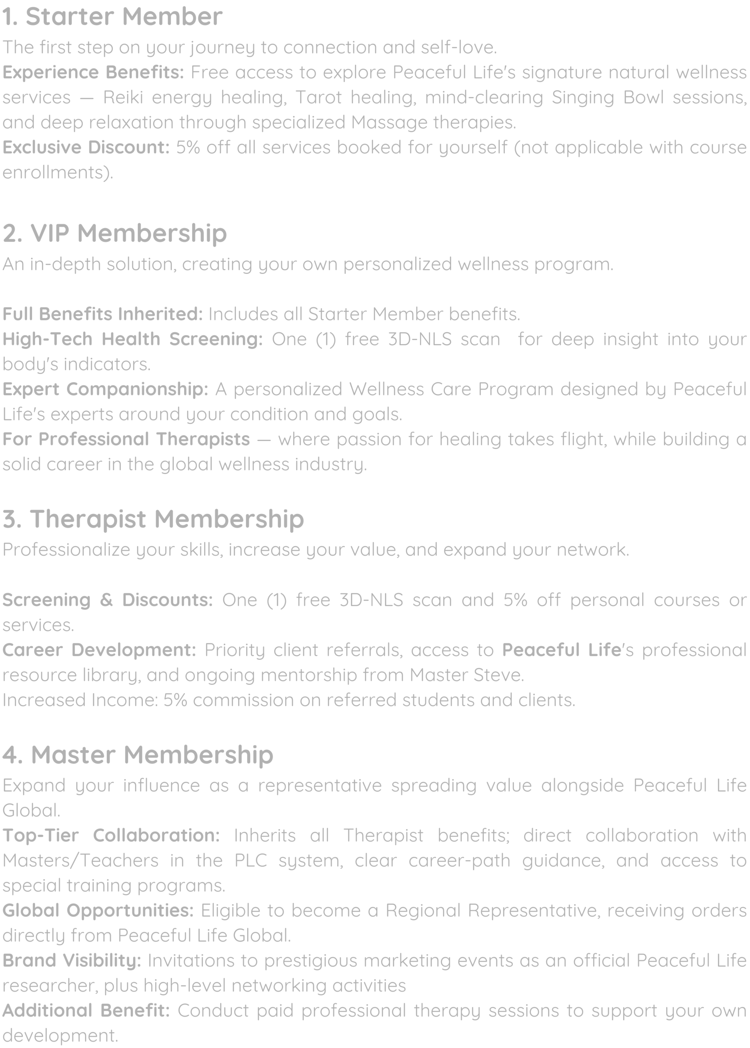
MEMBERSHIP PROGRAMS
43
ONLINE SERVICES
A pathway of connection, growth, and shared purpose within the Peaceful Life

Starter Member
The first step on your journey to connection and self-love.
Experience Benefits: Free access to explore Peaceful Life's signature natural wellness services — Reiki energy healing, Tarot healing, mind-clearing Singing Bowl sessions, and deep relaxation through specialized Massage therapies.
Exclusive Discount: 5% off all services booked for yourself (not applicable with course enrollments).

VIP Membership
An in-depth solution, creating your own personalized wellness program.

Full Benefits Inherited: Includes all Starter Member benefits.
High-Tech Health Screening: One (1) free 3D-NLS scan for deep insight into your body's indicators.
Expert Companionship: A personalized Wellness Care Program designed by Peaceful Life's experts around your condition and goals.
For Professional Therapists — where passion for healing takes flight, while building a solid career in the global wellness industry.

Therapist Membership
Professionalize your skills, increase your value, and expand your network.

Screening & Discounts: One (1) free 3D-NLS scan and 5% off personal courses or services.
Career Development: Priority client referrals, access to Peaceful Life's professional resource library, and ongoing mentorship from Master Steve.
Increased Income: 5% commission on referred students and clients.

Master Membership
Expand your influence as a representative spreading value alongside Peaceful Life Global.
Top-Tier Collaboration: Inherits all Therapist benefits; direct collaboration with Masters/Teachers in the PLC system, clear career-path guidance, and access to special training programs.
Global Opportunities: Eligible to become a Regional Representative, receiving orders directly from Peaceful Life Global.
Brand Visibility: Invitations to prestigious marketing events as an official Peaceful Life researcher, plus high-level networking activities
Additional Benefit: Conduct paid professional therapy sessions to support your own development.

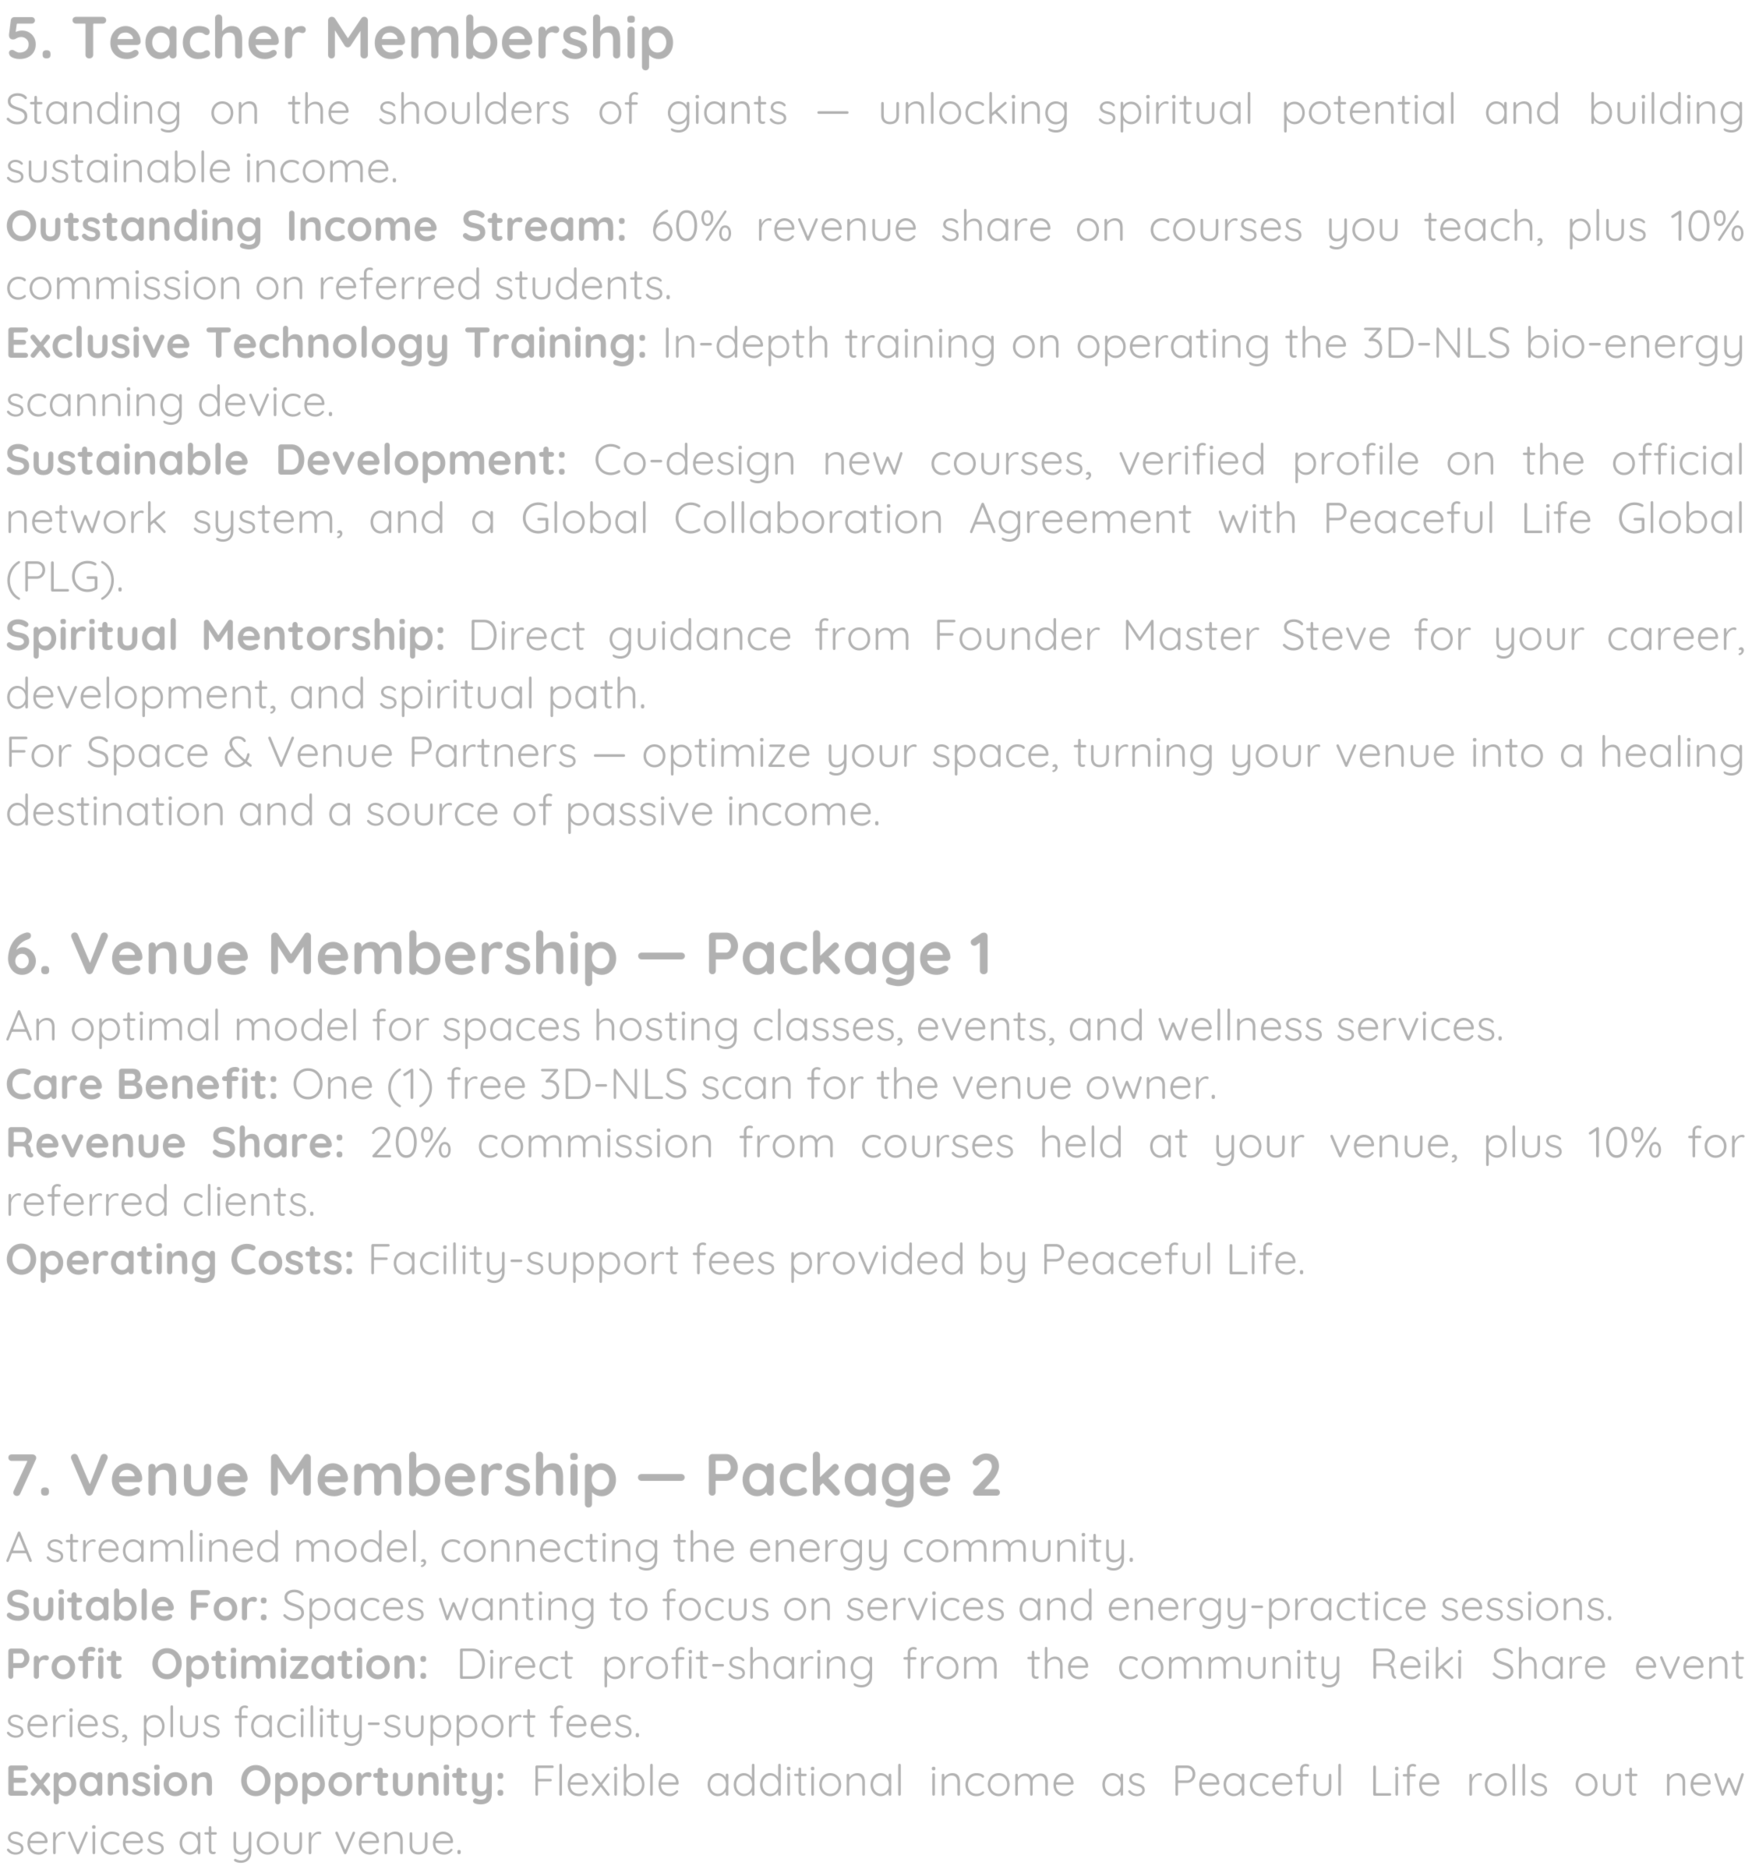
MEMBERSHIP PROGRAMS
44
ONLINE SERVICES
A pathway of connection, growth, and shared purpose within the Peaceful Life

Teacher Membership
Standing on the shoulders of giants — unlocking spiritual potential and building sustainable income.
Outstanding Income Stream: 60% revenue share on courses you teach, plus 10% commission on referred students.
Exclusive Technology Training: In-depth training on operating the 3D-NLS bio-energy scanning device.
Sustainable Development: Co-design new courses, verified profile on the official network system, and a Global Collaboration Agreement with Peaceful Life Global (PLG).
Spiritual Mentorship: Direct guidance from Founder Master Steve for your career, development, and spiritual path.
For Space & Venue Partners — optimize your space, turning your venue into a healing destination and a source of passive income.

Venue Membership — Package 1
An optimal model for spaces hosting classes, events, and wellness services.
Care Benefit: One (1) free 3D-NLS scan for the venue owner.
Revenue Share: 20% commission from courses held at your venue, plus 10% for referred clients.
Operating Costs: Facility-support fees provided by Peaceful Life.

Venue Membership — Package 2
A streamlined model, connecting the energy community.
Suitable For: Spaces wanting to focus on services and energy-practice sessions. Profit Optimization: Direct profit-sharing from the community Reiki Share event series, plus facility-support fees.
Expansion Opportunity: Flexible additional income as Peaceful Life rolls out new services at your venue.

45

ANNUAL EVENT

A Truly Unique Spiritual Event

People from across the world come together to share, learn and grow — reconnecting with themselves, with each other, and with the spirit of life. Gifted teachers and practitioners lead ceremonies, workshops and healing sessions around the sacred fire.

APRIL
SEPTEMBER
NOVEMBER

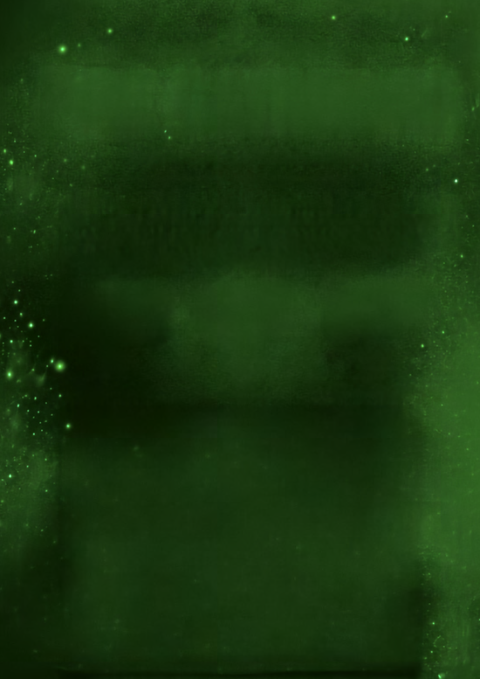


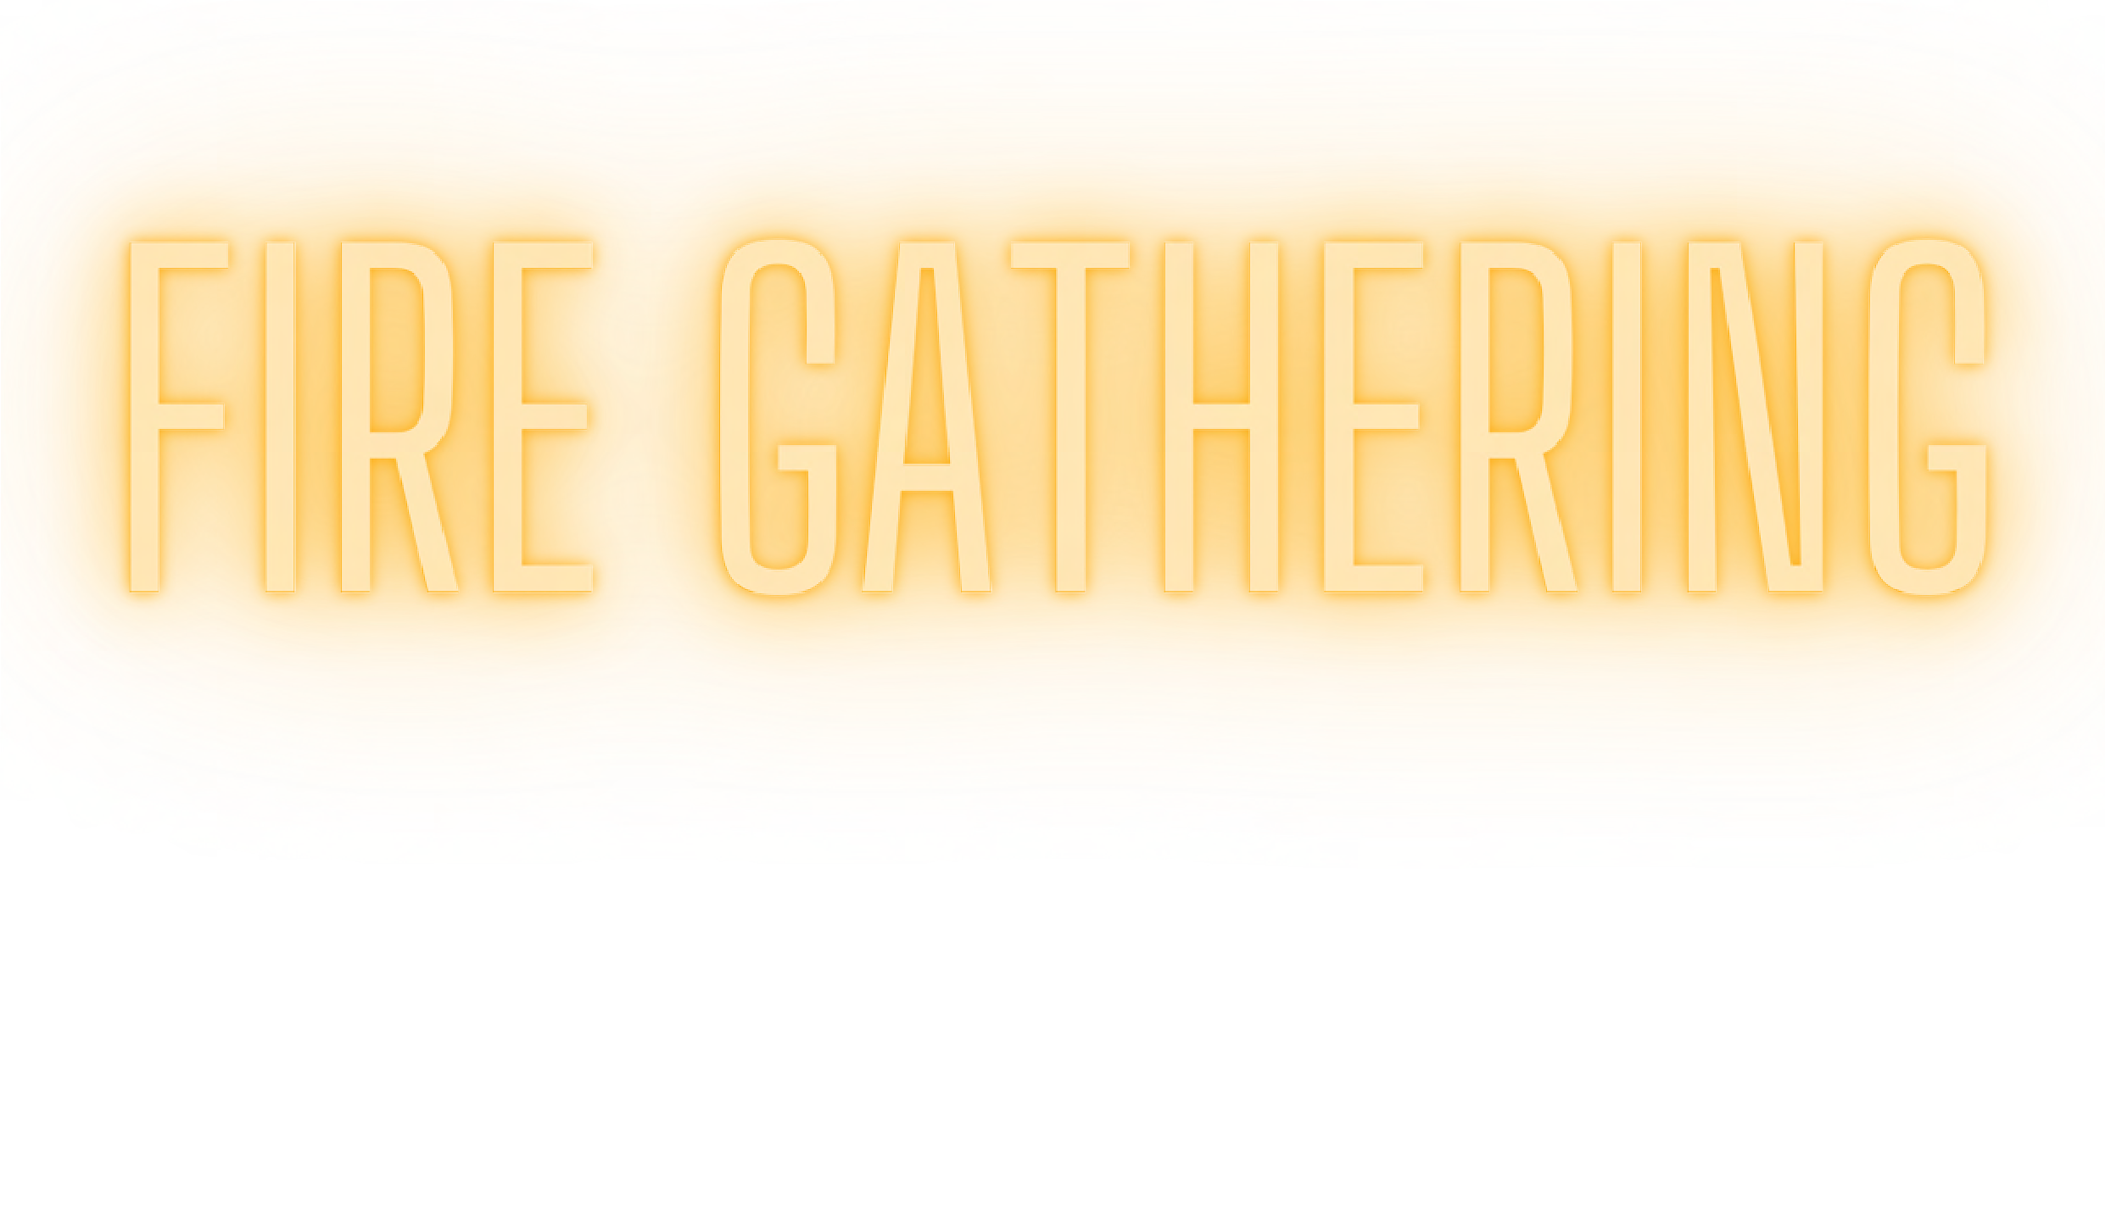




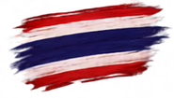

At the Fire-Lighting Ceremony, this special transformation journey lasts continuous days and nights. Accompanied by teachers and therapists from Australia, Thailand, and Vietnam, you'll not only take energy courses (Siam Reiki 1, 2, DPA...) but also experience disciplines built on the foundation of loving energy and wisdom, such as Yoga, Transformational Painting, Card Reading, Aura Reading, and Massage.

In addition, the services offered beside the sacred fire are also special, including distance healing by the Sacred Fire, and soul liberation and connection with departed loved ones. This gives those who cannot attend in person the opportunity to still receive healing energy within 24 hours, helping to comprehensively transform blockages.

Are you ready to step into the sacred circle of fire, where transformative miracles await you?

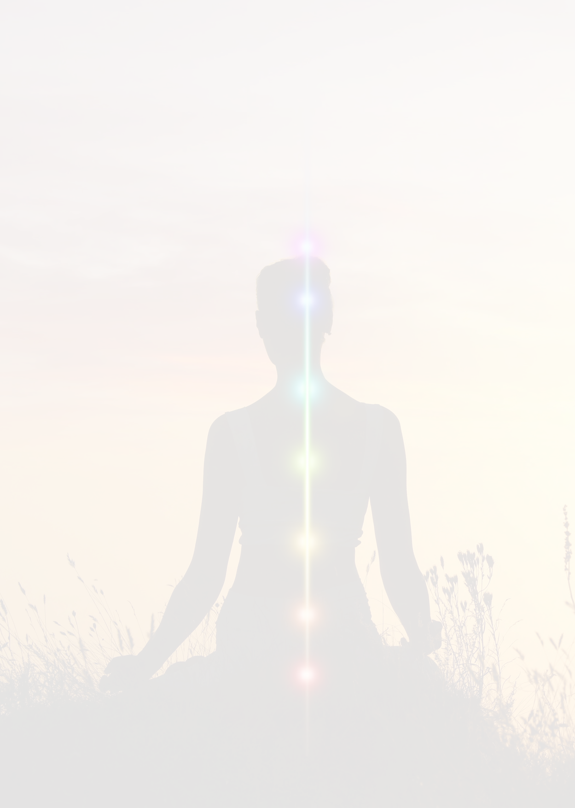
In-Depth Spiritual Research & Discovery Tour
46
ONLINE SERVICES
Ancient temples were never built by chance. Every brick and statue — back to mountain, face to river — reflects timeless feng shui and rests on pure geomantic energy.
For those drawn to ancient stories and sacred energy, Peaceful Life offers this journey: not a pilgrimage, but a deep dive into knowledge and connection for true enthusiasts. Admire masterful temple architecture and sculpture across dynasties, learn the meaning behind spiritual symbols and altar arrangements, and hear the legends behind each temple's founding.

The highlight: standing on "dragon vein" lands, where powerful feng shui creates a pure energy field that shifts mind and body. The pace is slow, leaving time to linger before ancient carvings and windswept courtyards.

- What does this tour offer?
Discover the true energy behind sacred sites — knowledge unavailable online or in books. Travel with like-minded companions to high-energy places, guided by experienced practitioners who ensure safety throughout.

- How are customers supported?
Full pre-trip guidance is provided. Those with mobility difficulties are supported with wheelchairs, electric vehicles, or personal assistance. Guides share each site's energetic character and safe prayer practices, and address any energetic disturbances that arise.

- What do customers gain?
A deeper connection to the land, release of old karmic ties, and enriched knowledge of energy, geography, culture, and history. Those who've studied Transcending gain heightened sensitivity to Earth's energy. Under guided conditions, some may even help improve a site's energy, generating positive karma.

- Who is it for?
Anyone curious about lands from an energetic perspective, seeking knowledge not found elsewhere, or wanting to boost personal energy through sacred sites.

- Anything to note?
No special requirements — just follow the pre-trip guidelines.

- What makes it different?
Master Steve personally leads the group, teaching participants to sense energy while sharing deep knowledge of the Earth's energy sites — visiting high-energy locations, not typical tourist spots.

Destiny Day
47
ONLINE SERVICES

In the middle of a fast-paced, high-pressure life, Destiny Day — organized by Peaceful Life — is a "healing festival," a safe space to set worries aside and care for your Body, Mind, and Spirit.

Step into a mini fair full of positive energy, bringing together a wide range of therapy and wellness methods.

How You'll Experience It

Free & open entry — no ticket, no registration. Drop by anytime during event hours. Your choice — browse freely and only pay for what you want, starting from around 100k. No pressure, no pushy sales.
A trusted team — all therapists are trained and certified by Peaceful Life, with every service vetted by Master Steve and the expert team.

Benefits & Experiences

Everything in one space — relaxing massages, restorative yoga, quantum health scans (3D-NLS/EWS), painting, essential oil blending, aura reading, card reading, dream interpretation, and singing bowl sessions.
Flexible pricing — clearly listed at each booth, making it easy to try many healing methods in one day.
Connection — meet like-minded people, chat with therapists, and find the self-care methods that suit you.

How to Join

Follow Peaceful Life's social media for time and location.

Bring friends or family, come with an open mind, and our Supporters will help you register and get started.

Allow yourself to rest — Destiny Day is always open, welcoming you into a journey of understanding and loving yourself.

Silent Retreat
48
ONLINE SERVICES

Goal: 3 days of stillness to connect with your inner wisdom.

Suitable For: Anyone seeking answers, a new direction, or simply a long-overdue moment of inner peace. No prior energy work experience needed.

What to Prepare
A goal or wish — new career ideas, better communication, finding love, inner peace, intuition — or simply an intuition that this retreat will help you find what you need.
Notebook and pen for journaling.
Personal ritual items (candles, incense) if you use them. Personal items and any necessary medication.
No snacks or supplements — the program requires one meal a day.

Schedule
The evening before, participants arrive to settle in, hear an overview, and ask questions. The retreat runs 9:00 AM on day one to 6:00 PM on day three. Phones are held by organizers throughout — the goal is 3 phone-free days, with at most 1 hour of communication total, so the rest of the time can go toward inner connection.

What Makes It Special
A private space for each person, free from outside disturbance.
Daily private consultation with Master Steve, a martial arts master and spiritual teacher with nearly 30 years of experience guiding professionals toward greater clarity.

Daily Details

Each participant has their own private hotel room. 24/7 emergency contact equipment is provided, so support is always available without a phone.
Breakfast is the only meal of the day — eating within a short window supports stillness and inward reflection.
Herbal tea, juice, and filtered water are provided for cleansing throughout the day.
Each day includes a group session where Master Steve shares guidance and outlines focus goals.
Afterward, participants return to their rooms for a scheduled one-on-one consultation, with personal guidance and exercises prepared just for them.
Group sessions and individual consultations happen daily to ensure the program's effectiveness.

Reiki Share
49
ONLINE SERVICES

Reiki Share is a community activity held regularly by Peaceful Life, where Siam Reiki students practice under the guidance of a Siam Reiki Master, while also giving the community a chance to learn about and directly experience Siam Reiki in an open, safe, non-judgmental environment.

Throughout Reiki Share, the Siam Reiki Master and student team accompany participants at every step. Customers receive guidance before the session begins, support throughout, and answers to any questions afterward. Every feeling is respected, with no imposed interpretation or fixed framework — the team's role is simply to accompany and create the conditions for each person to observe and feel their own changes

The program is especially suited to three groups:
People experiencing stress and fatigue from prolonged pressure, who want time to relax, rebalance, and care for themselves.
People sensitive to energy, who often feel easily affected by their environment or others' emotions but don't yet know how to recognize and care for their own energetic state.
People interested in energy-based wellness methods but who still have questions, and want to experience it firsthand before deciding to study or use the service.

What do customers gain after the experience?
Directly experience the flow of Siam Reiki energy.
Gain a clearer understanding of the Siam Reiki method and the Peaceful Life community.
Gain new perspective on their own energetic and health state.
Better understand their own health condition through the 3D NLS device. Have time to relax, rest, and rebalance after life's pressures.
Release accumulated stress and negative energy.

Reiki Share is not just a Siam Reiki experience session, but a recurring community activity that spreads the culture of practicing, learning, and sharing within Siam Reiki. It's a place where students practice under the direct guidance of a Siam Reiki Master, while giving the community a chance to naturally access the method through hands-on experience rather than just theory.

Note : Reiki Share is a community experience activity and does not replace medical examination, diagnosis, or treatment.

ONLINFEasShioEnRDVesiIgCneEr S
Peaceful Life Charities



PLV Charity
The PLV Charity Fund is a bridge of compassion, originating from and sustained by the
contributions of teachers, therapists, and students within the Peaceful Life community. With a mission to spread loving energy from words into real action, the Fund focuses on community service activities, supporting and sharing with those facing hardship and disadvantage in society. Every contribution here is not only material support, but also a source of peaceful energy that brings renewed faith and hope to those in need of warmth.
The PLV Charity Fund is a social fund built from the hearts and contributions of the team of teachers, therapists, and students within the Peaceful Life community. Founded with the goal of service and sharing, the fund is where unconditional love is put into action through support activities that help those facing difficult circumstances in life. We believe that when the energy of unconditional love is spread, good values multiply, bringing peace and happiness to society.

PLG Charity
PLG Charity is a dedicated fund established to sustain and elevate the global Peaceful Life (PL) community.
Our funding source: Our charity fund is powered by the generosity of therapists and teachers within the community, and everyone who wishes to contribute to shared goals, aspirations, and activities.
Where the funds are used: 100% of contributions go directly to the PL community.
What we support: The fund directly sustains key projects, including Internship Programs, annual Fire Gatherings, and other community activities designed for the benefit of everyone.

Contact the Admin if you'd like to contribute to the development of this PL fund.

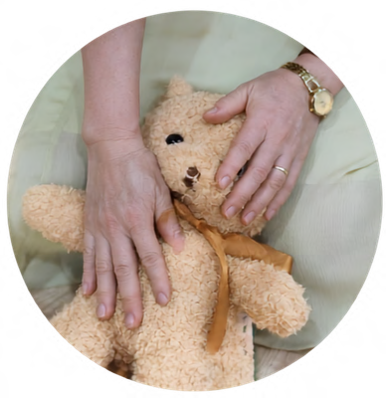




51
ONLINE SERVICES

Online Services

Peaceful Life offers a range of healing and wellness services for your body, energy, and spirit.

Distance Reiki Treatment

With Siam Reiki Master(Level 3)
A distance treatment session with a Siam Reiki Master lasts about 60 minutes. Afterward, you will receive a treatment report and consultation from the Reiki Master. All Siam Reiki Masters are required to complete every course in Peaceful Life's three-level Siam Reiki program, know how to use a dowsing pendulum and crystals, and be able to use psychic ability and clear dense/dark energy.
They must have a minimum of one year of practice and at least 40 in-person treatment sessions before becoming a professional therapist within the system. All of your treatment reports — whether from different Reiki Masters or therapists — are stored and tracked for future reference if needed.
There are no special requirements for you when receiving distance Reiki, but we recommend preparing a quiet space with a comfortable place to lie down, and setting aside time to feel the healing Reiki energy flowing through you.
Procedure:
Step 1: The client sends a photo and full name, and chooses the date they would like to receive treatment.
Step 2: The Master reviews the client's photo and selects the appropriate Master to perform the treatment.
Step 3: On the day the distance Reiki session takes place, the client continues their normal daily activities without any strong physical intervention required. The Master connects energetically with the client through the photo and carries out the treatment within an energetically protected space.
Step 4: Within 24 hours after the Reiki session, the client receives a report on their energy condition during the session, along with recommendations for improvement.
Step 5: A 15-minute live Zoom call with the Master to answer any questions the client has after the Reiki session.


52
ONLINE SERVICES
Online Services

Distance Reiki Treatment

With Siam Reiki Level 5

A distance treatment session with Siam Reiki Level 5 lasts about 60 minutes. Afterward, you will receive a treatment report and consultation from the Reiki Master. All of your treatment reports, regardless of which level of Reiki Master provided them, are stored and tracked for future reference if needed.
There are no special requirements for you when receiving distance Reiki, but we recommend preparing a quiet space with a comfortable place to lie down, and setting aside time to feel the healing Reiki energy flowing through you.

Procedure :

Step 1: The client sends a photo and full name, and chooses the date they would like to receive treatment.
Step 2: The Master reviews the client's photo and selects the appropriate Master to perform the treatment.
Step 3: On the day the distance Reiki session takes place, the client continues their normal daily activities without any strong physical intervention required. The Master connects energetically with the client through the photo and carries out the treatment within an energetically protected space.
Step 4: Within 24 hours after the Reiki session, the client receives a report on their energy condition during the session, along with recommendations for improvement.
Step 5: A 15-minute live Zoom call with the Master to answer any questions the client has after the Reiki session.

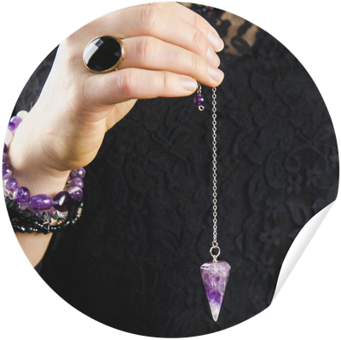

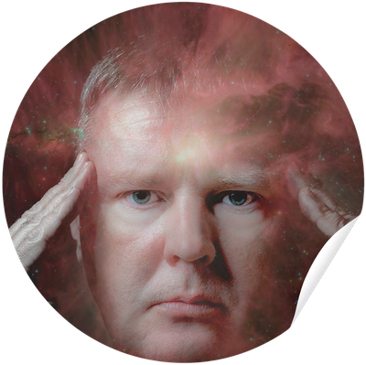
53
ONLINE SERVICES
Online Services

Pendulum Diagnosis
Duration: 30 minutes

(Online)
Are you looking for a deeper answer to your own issues? Or are you unsure and unable to find the root cause of blockages in your physical body, emotions, and energy?

Peaceful Life's distance dowsing-pendulum diagnostic service will help you find answers and solutions to the difficulties you are facing. The pendulum helps read blockages across the layers of the body, providing a reference point and helping you find ways to better care for yourself.

With the distance pendulum diagnostic service, you do not need to visit a treatment location. After the diagnostic session ends, you will receive advice and recommendations for your current health condition.
The session takes place online via Zoom, one-on-one (i.e., one client : one therapist). The therapist will take in your questions and provide answers through pendulum diagnosis.

Explore Your Extrasensory Perception

(Online with Master Khanh Vu (Kun))

DISCOVER YOUR STRONGEST EXTRASENSORY ABILITY

Have you ever been curious about your strongest extrasensory ability?
Each of us possesses our own extrasensory abilities, and these abilities help guide our soul's development journey in the right direction. Whether you "see" images, "hear" sounds, "feel" through the body, or simply "know" without knowing why — that ability is a natural part of you, waiting to be unlocked and developed in the right way.
Through the messages of the cards, Master Kun will decode your extrasensory ability during the Card-reading session.
Duration: 15 minutes

Requirement: Must have completed Siam Reiki Level 1.

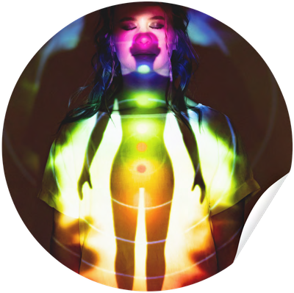
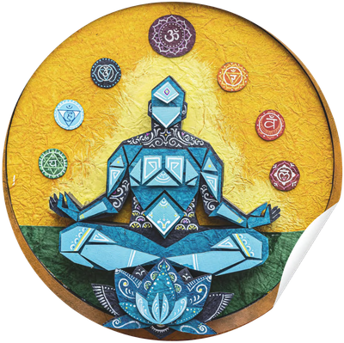
54
ONLINE SERVICES
Online Services

Aura Reading

with Siam Reiki Level 2 Practitioner
The physical, mental, emotional, and spiritual bodies together form an energy field surrounding the body, known as the Aura.
An Aura Reading session gives you an overview of your health and energy state across the four bodies: physical, mental, emotional, and spiritual. You will also receive suitable guidance to gradually restore balance and improve your health and quality of life.
Duration: 30 minutes

Everyone has a different energy state, so the outcome of each Aura Reading session will differ. However, a typical session includes:
Checking the outer layer of the aura and identifying the main points of imbalance. Checking the etheric aura layer (energy body) and identifying points to note. Checking the chakra system and identifying the main points of imbalance.
Advice based on the aura's condition, since your energy is closely linked to your health and life experiences.
Note: An Aura Reading session is for assessment and advice only; it does not include treatment, clearing, or releasing energy blockages. If you would like more in-depth support to balance and transform your energy, please book a Siam Reiki Treatment.

Aura Reading

with Siam Reiki Level 3 Therapist
This session is performed by a Siam Reiki Master, whose advanced training and years of experience allow for a more precise, nuanced reading — picking up on subtler patterns and offering deeper insight, especially useful for complex health concerns or major life transitions.
Duration: 30 minutes
A typical session includes:
Checking the aura's outer layer, with a Master's refined sensitivity to subtle imbalances Checking the etheric layer (energy body) for deeper points to note
Checking the chakra system, drawing on broader diagnostic experience Advanced, personalized guidance based on your aura's condition

55
ONLINE SERVICES
Online Services

Online Card Reading

with Siam Reiki Level 2 Practitioner
The card-reading process is a transformative journey that allows everyone to seek answers to questions about many aspects of life. Whether it's about career, finances, health, relationships, family, or business — or even "unconventional" matters such as communicating with pets or finding lost items
— you can ask your question and the cards will be read in combination, matching the type of question.

Whatever your question is about, a card-reading session is a healing session with clear guidance, helping you recognize your imperfections, develop personally, and steer your life according to the values your heart holds dear.
Duration: 30 minutes

Online Card Reading

with Siam Reiki Level 2 Practitioner
The card-reading process is a transformative journey that allows everyone to seek answers to questions about many aspects of life. Whether it's about career, finances, health, relationships, family, or business — or even "unconventional" matters such as communicating with pets or finding lost items
— you can ask your question and the cards will be read in combination, matching the type of question.

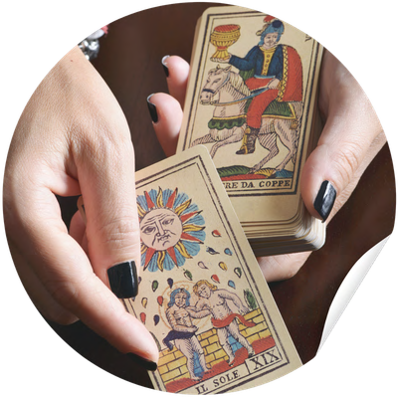
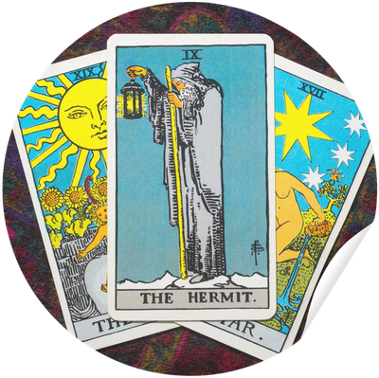
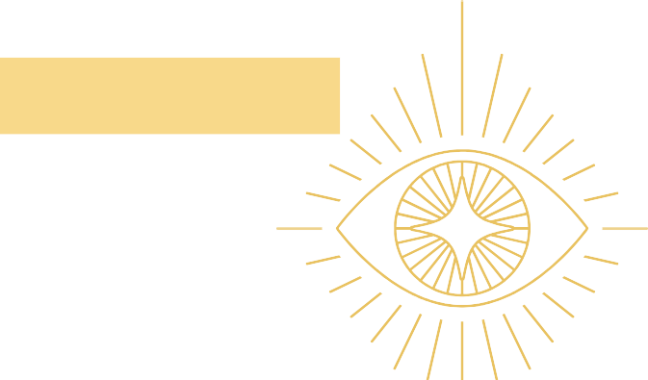
Duration: 60 minutes
Whatever your question is about, a card-reading session is a healing session with clear guidance, helping you recognize your imperfections, develop personally, and steer your life according to the values your heart holds dear.

56
ONLINE SERVICES
Online Services

Online Card Reading

with Siam Reiki Level 3 Master
Ideal for specific or time-sensitive concerns, this session allows for sharper insight into areas such as career decisions, relationships, finances, health, or personal growth. The card combinations are interpreted with heightened intuitive connection, offering not just answers, but clear direction and actionable understanding.

Level 3 readings are especially suited for individuals who are ready to move forward with confidence, gain clarity on complex situations, or deepen their self-awareness through a more refined and high-frequency reading experience.
Duration: 30 minutes

Online Card Reading

with Siam Reiki Level 3 Master
Ideal for specific or time-sensitive concerns, this session allows for sharper insight into areas such as career decisions, relationships, finances, health, or personal growth. The card combinations are interpreted with heightened intuitive connection, offering not just answers, but clear direction and actionable understanding.



Duration: 60 minutes
Level 3 readings are especially suited for individuals who are ready to move forward with confidence, gain clarity on complex situations, or deepen their self-awareness through a more refined and high-frequency reading experience.

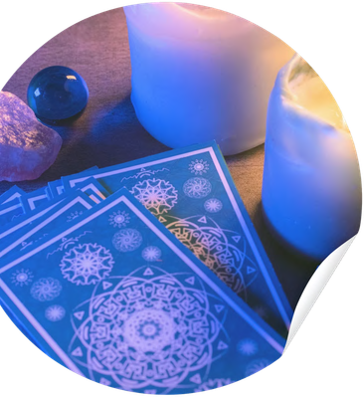
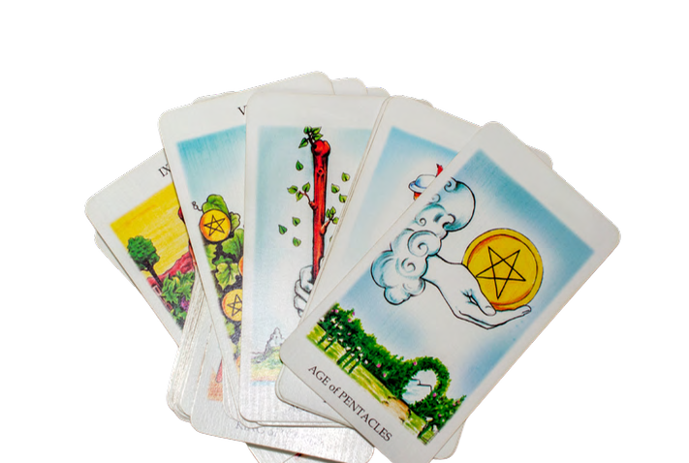
57
ONLINE SERVICES
Online Services

Soul-Level Card Reading
DISCOVER INFORMATION THROUGH OVERSOUL-LEVEL CARDS
The Oversoul-Level Card Reading service is a special journey that helps you connect deeply with your soul's purpose and your oversoul — where every experience in your current life has a deep-rooted cause at the soul level.
During the reading, you will receive answers to core questions: What is your soul's goal and plan in this lifetime? What karma is affecting your development journey? Are you on the right path toward your soul's purpose? Are your relationships, work, and current choices part of that journey?
Duration: 60 minutes

Unlike a Reiki session, in which energy heals itself, an oversoul-level card reading allows you to actively access and identify unresolved blockages and karma — opening the way for transformation at the deepest level.
This is one of the specialized, in-depth services researched, developed, and taught by Peaceful Life's team of experts — for those who truly wish to understand themselves at the soul level and take steadier steps of awakening on their life journey.


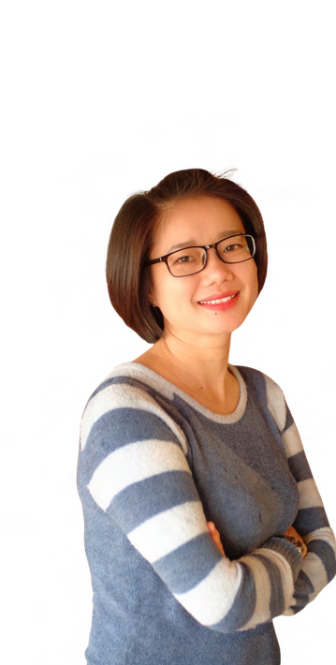
58
ONLINE SERVICES

Online Services

Online/Offline

Soul-Plan Card Reading
DISCOVER YOUR SOUL'S PLAN THROUGH CARDS

The Oversoul-Level Soul Plan Card Reading service is a special journey that helps you connect deeply with your soul's purpose and your oversoul — where every experience in your current life has a deep-rooted cause at the soul level.
During the reading, you will receive answers to core questions: What is your soul's goal and plan in this lifetime? What karma is affecting your development journey? Are you on the right path toward your soul's purpose? Are your relationships, work, and current choices part of that journey?
Duration: 120 minutes

This is one of the specialized, in-depth services researched, developed, and taught by Peaceful Life's team of experts — for those who truly wish to understand themselves at the soul level and take steadier steps of awakening on their life journey.

One-on-One Counselling with Winnie

Location: HCM
A Space for Healing & Emotional Release Here, you will step into a safe and warm space where inner wounds are gently soothed.
This service helps you with:
Non-judgmental listening: Your thoughts and story are received fully with empathy and pure care, with absolutely no judgment or evaluation, and complete confidentiality. You are free to be your most natural self.
Emotional release: A place where you can remove your strong mask, freely express yourself, and let go of burdens, anxiety, or long-suppressed pain.
Tools to overcome difficulties: Beyond simply sharing, Master Winnie accompanies and guides you through concrete, practical exercises.

These methods help you turn inward, learn to make peace with your wounds, and awaken your inner strength to overcome challenging situations.


59
ONLINE SERVICES
Online Services

I Ching Reading

Consultation
Strategic & Direction Consultation with the I Ching Are you standing at an important crossroads in your life? Do you need a deeper perspective to understand the times and make wise decisions?
Peaceful Life's I Ching Consultation service is not just about interpreting hexagrams — it combines ancient Eastern wisdom with modern problem-solving thinking. We help you examine hidden possibilities and find the most optimal course of action.
Why choose an I Ching consultation at Peaceful Life?
Understand the essence: See the root of the problem, not just the surface.
Predict trends: Know which times are "auspicious" (favorable) and which are "inauspicious" (calling for stillness).
Make decisions: Gain additional data to feel more confident in decisions about business, career, investment, or important relationships.
Peaceful Life's in-depth consultation areas support you in:
Career & Business: Development direction, timing for expansion or withdrawal, partner evaluation. Finance & Investment: Analysis of investment fortune, risk management amid market fluctuations. Personal life: Important milestones, personal development direction, or resolving mental blocks.
Peaceful Life's commitments:
- Professional & Dedicated: We take the time to fully listen to your story and analyze the hexagram thoroughly.
- Multi-perspective view: We don't impose; we offer possibilities and suggested solutions so you remain the one who makes the final choice.
- Absolute confidentiality: All client information and personal data are kept completely confidential.
- Transparency: No scare tactics, no profiting through spirituality. We aim for peace and a positive outlook for our clients.
Process:
- Receiving the issue: You send your question/current situation (the more detail, the more accurate the analysis).
- Casting the hexagram: Using an authentic hexagram-casting method (by time, by event, or on request).
- Interpreting & consulting: You receive an in-depth analysis (in writing or through direct discussion).
- Providing solutions: We discuss together to turn the hexagram's messages into a concrete action plan.
Contact the Admin to begin your consultation session today.
Note: This service is for reference purposes based on classical knowledge. The final decision always rests with your own effort and wisdom.

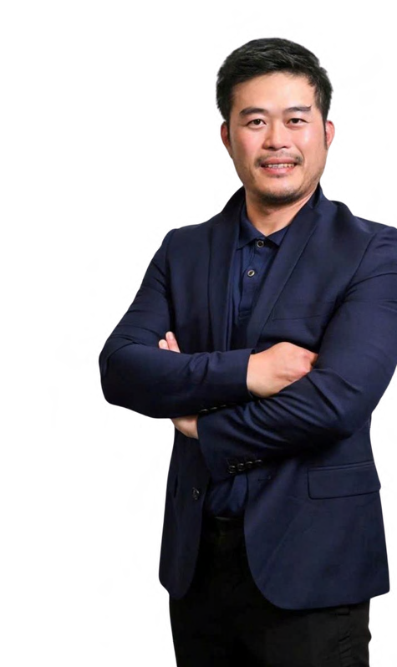
60
ONLINE SERVICES
Online Services

Consultation from Esoteric Disciplines

Esoteric Advisory
Consultation and Problem-Solving through Esoteric Studies
Sometimes we find ourselves in extremely challenging and stuck situations — whether it's career, finances, marital trouble, relationships, health, or feng shui issues at home. When ordinary methods struggle to resolve them, this service can help you turn adversity around.

With more than 20 years of in-depth practical experience, Master Bruce applies the essence of Eastern esoteric disciplines such as Tu Vi (Purple Star Astrology), the I Ching, Feng Shui, and Qi Men Dun Jia… to decode the root of the problem and provide effective methods to "change fate" and resolve the situation.
Transparent two-stage service process:

Part 1: Analysis & Proposed Solution — Master Bruce conducts a comprehensive assessment of your situation and drafts a specific, optimal solution. (The fee for this consultation and analysis is quoted separately.)

Part 2: Implementing the Solution — After hearing the analysis, if you fully understand and agree with the proposed plan, Master Bruce then carries out the in-depth resolution procedures.
The implementation fee is charged separately, based on agreement.
Specific Quality Commitment & Warranty:

To provide clients with complete peace of mind and ensure the service's reliability, the service includes a 3-month warranty policy. We also apply a clear, transparent refund policy for specific cases detailed in the contract signed between both parties.





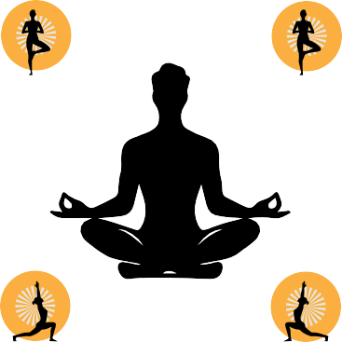

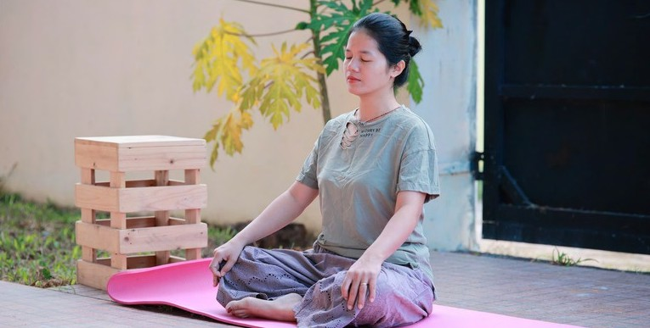
61
ONLINE SERVICES
Online Services

One-on-One Personal Yoga

with Teacher Ngoc Diep

Discover a body-mind connection journey designed entirely for you. The 75-minute one-on-one personal yoga class with Teacher Ngoc Diep is a safe, professional space where every exercise is designed and adjusted based on your exact physical condition and goals.
The class perfectly serves two specialized needs:
Therapeutic & Restorative Yoga: For those facing recovery from injury,
spinal , neck/shoulder problems, or nervous tension. Exercises focus on gentle stretching combined with deep breathing to release blockages, ease pain, and activate the body's natural self-healing ability.
Goal-Focused Yoga: If you are seeking flexibility, wanting to build core strength, improve your physique, or aiming to master advanced poses (asanas), a program will be built at a suitable intensity. You will receive detailed guidance on every technique, ensuring safety and sustainable results.
Why choose this 75-minute yoga program?
With a 75-minute duration, you'll have enough time for a thorough warm-up, in-depth practice, and direct, hands-on pose correction from Teacher Ngoc Diep, tailored to your individual condition, for the safest and best results.
Duration: 75 minutes

62
ONLINE SERVICES

Online Services

Peaceful Life Students

Draw Guide
Location: HCM
Have you ever heard someone say you have a spiritual guide — and if so, who are they? What do they look like, what colors, how old are they?
Which realm do they come from? Earth, somewhere above the sky — are they extraterrestrial? Do they come from a sacred, supreme realm?
Since when have they been with you, and why did they choose you? What sacred, supreme purpose brought them to you?
What area will they help and support you in? What is your mission and theirs?
How do they guide you in detail while maintaining a sacred, unconditional connection and purpose?
Is it a safe connection?
All of these questions will be answered together with Master Qiti of Siam Reiki, who will draw the images of these guides in her own charming drawing style. The style is very simple and rustic… but it is drawn using energy from the spirit world.

Draw Guide

New Clients
Have you ever heard someone say you have a spiritual guide — and if so, who are they?
What do they look like, what colors, how old are they? Which realm do they come from? Earth, somewhere above the sky — are they extraterrestrial?
Do they come from a sacred, supreme realm?

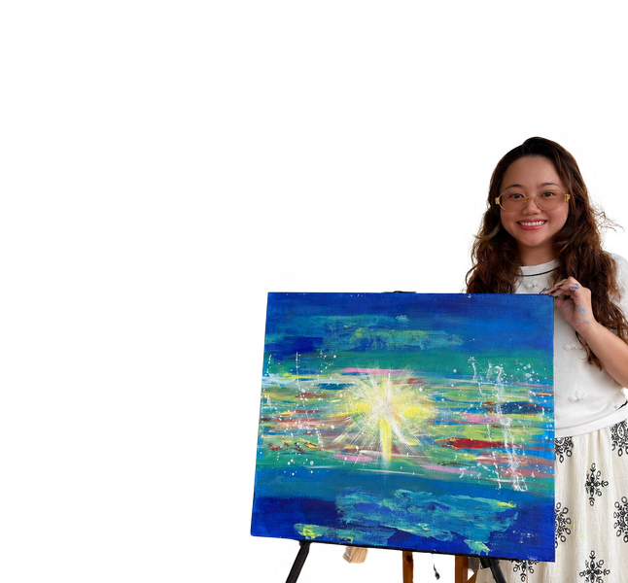
Since when have they been with you, and why did they choose you?
What sacred, supreme purpose brought them to you? What area will they help and support you in? What is your mission and theirs?
How do they guide you in detail while maintaining a sacred, unconditional connection and purpose?
Is it a safe connection?

Master Qiti

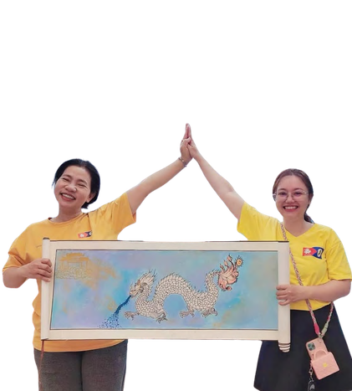
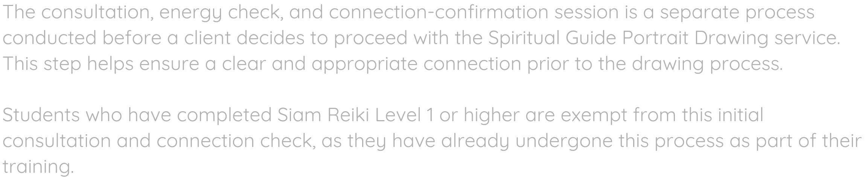
63
ONLINE SERVICES

Online Services

Consultation for Client (Not a PL student)

Draw Guide
Location: HCM
20 .Guide Drawing Service (Open to Non-PL Students Worldwide)
Location: HCM
The consultation, energy check, and connection-confirmation session is a separate process conducted before a client decides to proceed with the Spiritual Guide Portrait Drawing service. This step helps ensure a clear and appropriate connection prior to the drawing process.

Students who have completed Siam Reiki Level 1 or higher are exempt from this initial consultation and connection check, as they have already undergone this process as part of their training.

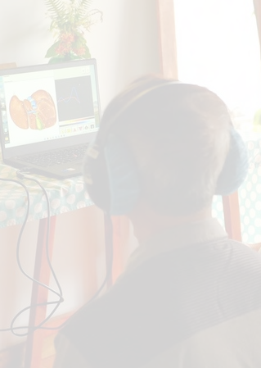
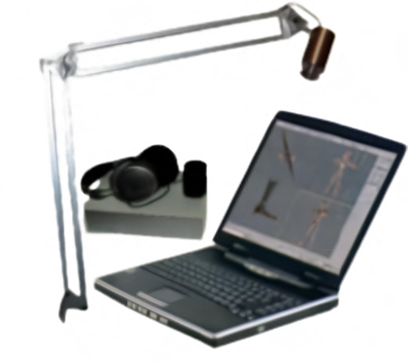


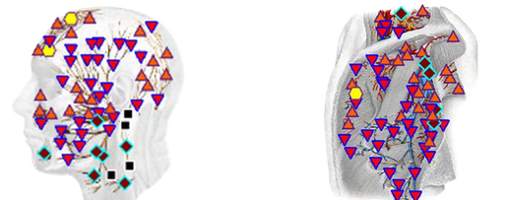
64
ONLINE SERVICES
In Person Services

3D-NLS Scan

In-Depth Health Measurement with 3D-NLS Scanning
Technology
The in-depth Scan package using the 3D-NLS device is a
45-minute comprehensive review that helps you thoroughly understand your body, analyzing everything from major organ systems down to the finest energy layers.

When you take part in the in-depth Scan package, you will receive:

Comprehensive energy-structure scan: A detailed review of every micro signal point on the body, down to the molecular level.

Extraction & in-depth analysis: The system identifies and selects up to 5 areas
with the highest degree of energy imbalance. Comparing this energy spectrum with standard reference parameters allows the expert to give the most accurate assessment.

Personalized recovery roadmap: Based on the measurement results, the expert directly assesses, highlights priority issues, and designs a specific balancing plan (including essential foods, exercises, and lifestyle) to restore the body's natural frequency.

Transparent health report: At the end of the session, you will receive a detailed analysis report from the Admin to keep and track your health journey.
Exclusive Policy for Peaceful Life Members
Members receive one free scan and a consultation on the optimal health-care roadmap from Master Steve.

Internal offers & privileges: Complimentary experience passes for friends and family at community events, and preferential rates for additional services.

Note: Specific benefit details may vary depending on the contract and policy of each membership package.

65
ONLINE SERVICES
In Person Services

EWS Scan — Vitamin and Mineral Deficiency Scan
Experience Body Measurement with the EWS Biophilia Early Warning System
Location: HCM, Ha Noi
In just a few minutes, the EWS Biophilia system uses a handheld sensor to collect subtle bio-electromagnetic wave patterns and analyse them through advanced quantum resonance spectrum technology, providing a comprehensive overview of your current health condition.
After the scan and a brief consultation, you will receive a detailed report covering:
- Actual Measurement Indicators – A comparison of your organ systems against healthy reference ranges, helping identify potential imbalances and areas that may need attention.
- Body & Nutrition Assessment – Insights into muscle-to-fat ratio, nutrient absorption, vitamin and mineral levels, toxins, heavy metals, and a healthy target weight range suited to your body.
- Personalised Care Recommendations – Practical guidance on sleep, nutrition, and lifestyle habits to support balance and overall wellbeing.
Results: You will receive a comprehensive 100-page report to keep and track your health journey over time.

- Meta-Therapy
Support for Pain/Illness Relief via Meta Waves
Location: HCM, Ha Noi

Meta-Therapy: Support for Recovery & Pain Relief via Bio-Waves

Meta-Therapy is an in-depth health support method for individuals with weakened conditions or multiple areas requiring special care. It can be used alongside existing treatment plans to support the body’s recovery process.
Session Process (approximately 60 minutes):
- 3D-NLS Assessment – A comprehensive scan helps identify weakened or energy-imbalanced areas within the body.
- Meta Bio-Wave Application – Targeted bio-waves are directed to the 5–10 areas needing the most support, with the aim of promoting balance and cellular wellbeing.

Recommended Program & Outcomes
For optimal results, sessions are commonly scheduled every 3–4 days over a period of 1–3 months, depending on individual needs. Many clients report reduced discomfort, improved wellbeing, and positive changes in their overall health indicators.

A Safe Space for Community Healing
It's a gathering created to help people reconnect with their Body, Mind, and Spirit through shared Reiki energy.

Reiki Share

A Guide to Community Healing
ONLINE SERVICES
66
In Person Services
Locations :HCM, Ha Noi, Hoi An, Nha Trang, Da Lat Singapore, Rayong,
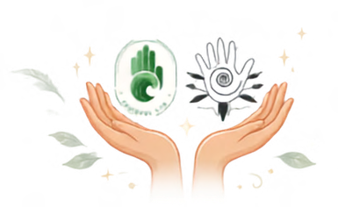

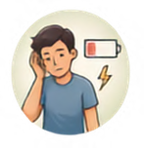

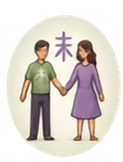
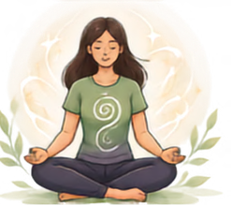
Rockhampton, Bundaberg, Perth for Australia

What the Session Includes

Individuals Experiencing Stress or Fatigue
The session offers a peaceful environment to rest and recharge your energy.

Those Curious About Reiki
It's an ideal, low-pressure way to learn about and experience energy healing firsthand.


Open to Everyone
Focus on Gentle Support & Relaxation The session creates space for the body
and nervous system to settle, promoting balance, clarity, and
Group Energy Exchange
Participants both receive and share Reiki energy within a guided, collective setting.
Open Q&A Session
Time is dedicated to answering questions about Reiki and the principles of
Reiki Practitioners and Non-Practitioners
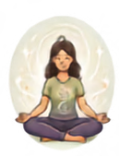
The gathering is welcoming to people at all levels of experience, from


No prior experience with Reiki or energy healing is required to participate fully and benefit from the session.
overall wellbeing.
energy healing.
seasoned masters to complete beginners.

An Experience, Not a Certification This is an experimental gathering for healing and connection, not a formal
training or certification
class.


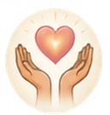
Guided, Heart-Centre Work
A facilitator leads the group through gentle, heart-focused energy work.
Community Connection & Sharing Participants are invited to share experiences from their personal healing journeys in a non-judgmental environment.

Anyone Seeking Gentle Energetic Support
If you are looking for a gentle way to enhance your sense of balance and wellbeing, this event is for you.

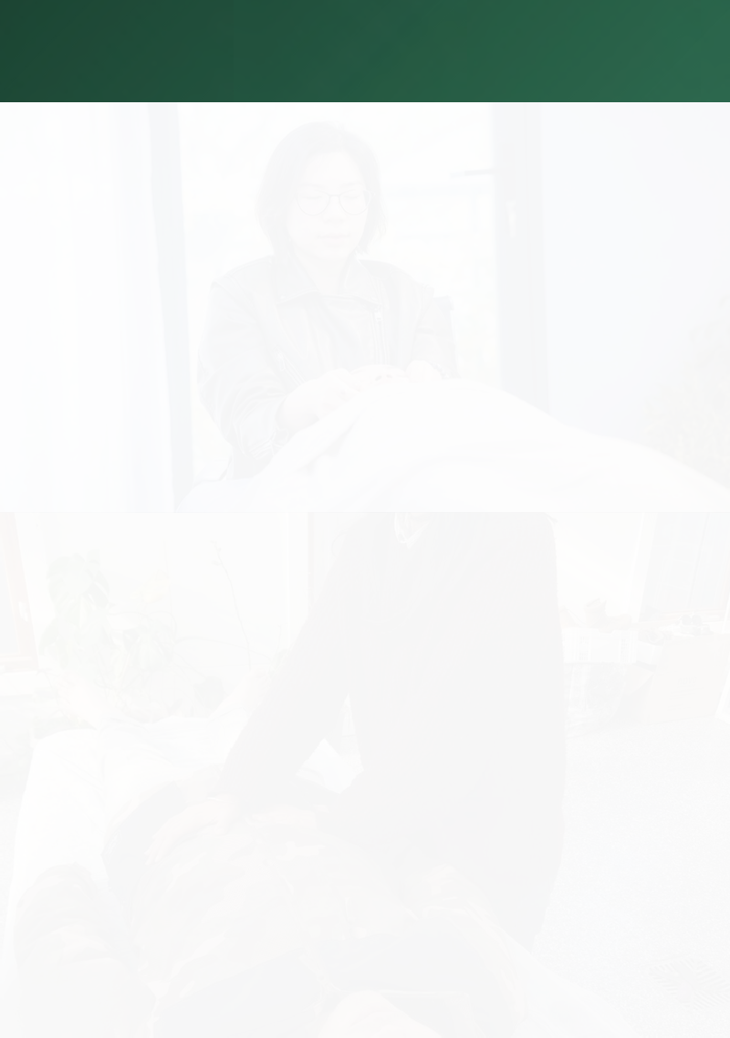
67
ONLINE SERVICES
In Person Services

Hands On Reiki Treatement

with Siam Reiki Level 3 Master
Location: HCM, Ha Noi, Da Nang, Hoi An, Da Lat, Rayong, Bundaberg

Are you facing issues with your physical body, emotional body, or energy body?
Do you want to heal blockages in your physical body and balance your mind and emotions?

Reiki treatment with a Siam Reiki Master is a wonderful choice for your healing and balancing journey.

Benefits of Reiki Treatment:
Creates balance and relaxation for body and soul
Boosts resistance and supports the body's natural self-healing; helps recovery after injury or promotes the reversal of illness
Duration: 60-90 minutes

Hands On Reiki Treatement

Level 5
Location: HCM
Are you facing issues with your physical body, emotional body, or energy body?
Do you want to heal blockages in your physical body and balance your mind and emotions?

Reiki treatment with a Siam Reiki Master is a wonderful choice for your healing and balancing journey.

Benefits of Reiki Treatment:
Creates balance and relaxation for body and soul
Boosts resistance and supports the body's natural self-healing; helps recovery after injury or promotes the reversal of illness

Duration: 60-90 minutes

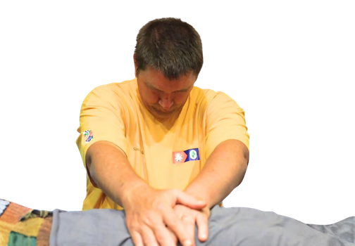
68
ONLINE SERVICES
In Person Services

Hands On Reiki Treatement

with Siam Reiki Level 9 Master Steve
Location: Worldwide
Experience a personal healing session directly with Master Steve, a Level 9 Siam Reiki Master. This one-on-one treatment is designed to support physical wellbeing, emotional balance, and energetic alignment through the powerful practice of Siam Reiki.

If you are experiencing physical discomfort, emotional stress, energetic blockages, or simply wish to restore harmony within yourself, receiving Reiki from Master Steve offers a deeply supportive path toward healing and renewal.

Benefits of a Reiki Session with Master Steve:
- Promotes deep relaxation and inner balance for body, mind, and spirit
- Helps release energetic and emotional blockages
- Supports the body's natural self-healing processes and recovery after illness or injury
- Strengthens vitality, resilience, and overall wellbeing
- Encourages greater clarity, peace, and emotional stability

Duration: 60-90 minutes





69
ONLINE SERVICES
In Person Services

One-on-One Singing Bowl
Duration: 60 minutes
Location: HCM, Ha Noi, Rayong
Singing bowls, with their sound and vibration, are an instantly effective therapy for emptying the mind and soothing the soul — even for those with a chaotic mind, emotional turmoil, or who are new to meditation. At the same time, the vibrations from the bowl travel deep into the physical body, bringing a sense of relaxation to every cell. The bowl's vibration frequency resonates with the chakra frequencies, helping balance the body's entire energy field.

Group Sound Bath
Location: HCM, Ha Noi, Rayong
Sound Bath Experience: Frequency Tuning — Comprehensive Mind-Body Healing
Benefits You Receive:
Physical: Fully releases tense muscle groups (shoulders, neck, back), reduces headaches, regulates blood circulation, and restores natural deep sleep.
Mind & Emotions: Instantly quiets overthinking, clears brain fog, and releases pent-up distress, anxiety, and suppressed wounds.
Energy & Spirit: Cleanses and balances the 7 chakras, protects the aura field, and activates a deeper connection to consciousness.
What Makes Us Different?
Fullmoon Himalayan Singing Bowls: We use 100% handcrafted bowls, cast on the night of the full moon, producing the purest range of vibration frequencies that penetrate deep into the cells to break through all blockages.
Personalized, Intuition-Based Therapy: There's no fixed script. The practitioner observes and listens deeply to your energy field to adjust the striking force and rhythm best suited to your body's state at that moment.
Integrated Siam Reiki Energy: Throughout the sound-bath session, practitioners act as a channel for Siam Reiki energy, helping cleanse the space, soothe wounds, and maximize each individual's own self-healing mechanism.
Duration: 60 minutes
Who Is This Service For?
People facing heavy pressure, severe stress, and depleted energy.
People with sleep disorders, chronic insomnia, or a sensitive, anxiety-prone nervous system. Those who have just gone through an emotional event or loss and need an absolutely safe space to pause, cry, release, and find balance.
A Few Notes Before Your Experience:
Clothing: Wear loose, soft, breathable clothing (avoid tight clothes or large metal buttons). Eating: Eat lightly at least 1 hour beforehand; avoid overeating to prevent discomfort when the bowl is placed on the stomach.
Condition: Do not consume alcohol or stimulants before the session.
Booking: Please book 1–2 days in advance so we can fully prepare the room and cleanse the energy space.
Slow down for a moment, step into the space of the Singing Bowl with Peaceful Life, and let your body rediscover its natural, peaceful rhythm!

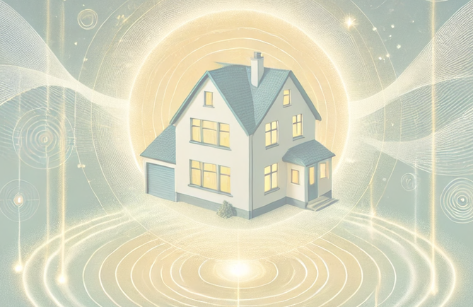
TThhee ggooaall ooff tthhiiss sseerrvviiccee iiss ffoorr yyoouu aanndd yyoouurr ffaammiillyy ttoo lliivvee iinn aa ssppaaccee wwiitthh aa ssaaffee eenneerrggyy ffiieelldd..

Land and House Cleansing
ONLINE SERVICES
70
In Person Services
Service

Restoring a Peaceful Living Space
Have you ever walked into your own home only to feel heavy, stifled, easily irritated, or frequently restless and unable to sleep? Sometimes a living space affected by blocked energy, geomagnetic intersections (ley lines, energy vortices, underground water veins), or lingering negative energies can quietly drain the vitality and spirit of your family.
The Land & House Energy Cleansing service, performed by Master Steve and Peaceful Life's cleansing expert team, is an in-depth intervention process to clean and re-establish the entire energy field of your space.
The service delivers these core values:
Deep Cleansing & Release: Thoroughly cleanses negative energy, traces of bad energy, remnants of black magic, and helps release foreign spirits from the land.
Protection Setup (one year): Your home and land receive an energetic protective boundary for the following 12 months.
Ongoing Support & Periodic Checks: During the protection period, the homeowner simply sends photos of the living space to Peaceful Life each month. Master Steve personally checks the home's energy condition and handles it appropriately.

IP Health Program
ONLINE SERVICES
71
In Person Services

A Comprehensive Recovery & Healing Journey
Location: Worldwide
In-Depth Health Care Program: A Comprehensive Recovery & Healing Journey

The body is a complex, interconnected system, and it needs to be understood and cared for holistically. Peaceful Life's (PL) In-Depth Health Care Program is a fully personalized roadmap combining modern technology, medicine, and natural healing methods to bring you the most optimal recovery results.

The Comprehensive Health Care process includes:
Comprehensive Screening & Assessment: Clients are examined in detail using in-depth 3D-NLS scanning technology. This result is combined with any hospital medical records/tests (if available) to create the most complete and accurate picture of your current condition.

Personalized Roadmap Setup: Based on the analyzed data, Master Steve and the expert team directly research, assess, and design a specialized care protocol. This roadmap flexibly lasts from 1 to 6 months, depending entirely on your health condition and recovery needs.

Multi-Method Therapy & Daily Monitoring: To achieve optimal results, the program involves multiple therapy experts across different methods (Reiki, Massage, Singing Bowl…). Every session is recorded in a detailed report. Master Steve and the expert team personally review the reports every day to track health progress and make timely professional adjustments.

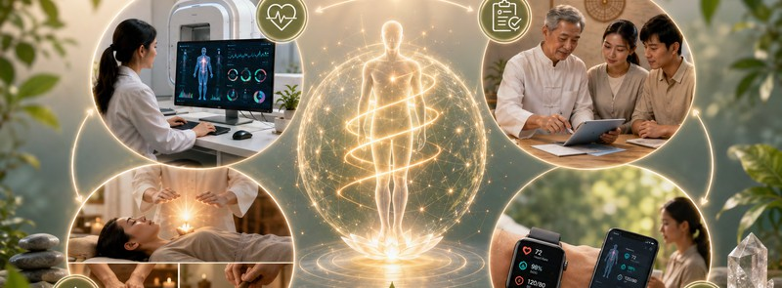
Technology-Assisted Support & Reassessment: Clients receive continuous care and support in daily life. PL provides a smart watch device to closely monitor the client's basic vital signs. Periodic scan schedules are also arranged to reassess recovery levels, ensuring the program stays on track and delivers the best results.

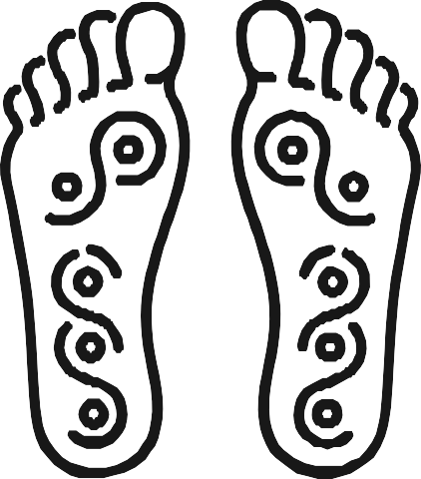

72
ONLINE SERVICES
In Person Services

Acupressure

Therapist: Nguyen Thi Tham (Cupping Lady)
Location: HCM
The human body is an intelligent, wondrous machine — within it lies a built-in mechanism for self-regulation, regeneration, and healing. But sometimes, blockages in the flow of energy cause that ability to stagnate, leaving you tired, stressed, sleepless, or with prolonged unexplained aches —
and that's when acupressure therapy shows its power.

The full-body acupressure service unblocks meridians, releases tension in muscle groups, and helps blood circulation.

Duration: 90 minutes

Slimming Massage

HOLISTIC WELLNESS MASSAGE COMBINED WITH
ABDOMINAL SLIMMING
Nourish the body from within, awaken natural beauty
The abdominal area is not just where excess fat accumulates — it's also closely connected to the digestive, endocrine, and emotional systems.

With this wellness massage combined with slimming treatment, you receive comprehensive care that not only helps reduce fat but also stimulates blood circulation, releases toxins, and provides deep full-body relaxation. The treatment includes a back massage to nourish the meridians and kidneys.
Duration: 90 minutes

Treatment includes:
Herbal hot wrap — softens fat, opens pores
In-depth acupressure massage — breaks down stubborn fat, promotes circulation. Herbal slimming compress — helps firm the skin and support detoxification

More than just slimming, this is a wellness therapy that helps you listen to your body, relax your mind, and renew your life energy every day.


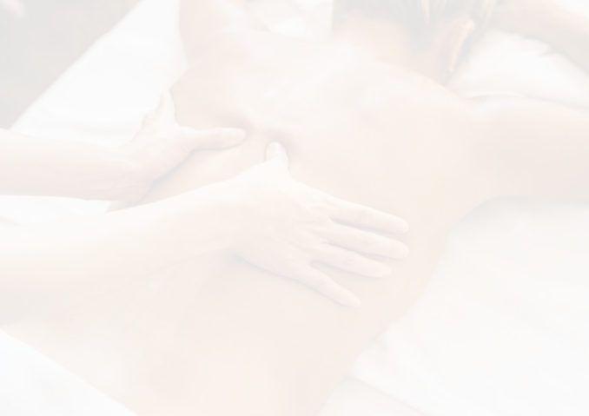
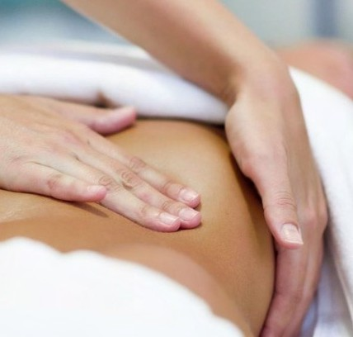

73
ONLINE SERVICES
In Person Services

Nurturing Massage

Abdominal Wellness Massage
Location: HCM
The abdominal massage process stimulates the digestive system, helps release excess gas, and reduces internal tension. Using gentle techniques, the therapist works on the acupoints around the navel, providing a relaxing feeling and improving circulation in the abdominal area.

Abdominal wellness massage process:
Hot wrap — 25 minutes Massage — 45 minutes
Herbal compress — 20 minutes
Duration: 90 minutes

Massage Body (Relaxing)

Full-Body Relaxing Massage
Location: HCM
- First, the client is checked and asked about their body's condition

- Based on the client's condition and preferences, a personalized plan is created for the massage session (if the client prefers a gentle massage, the movements will be gentle while still addressing issues such as soreness in a specific muscle area;

if the client prefers a firmer touch, or is stressed/sleepless, the session will help reduce stress and promote easier sleep, etc.) — on a basic level, this can also help adjust certain body imbalances such as mild postural stooping, etc.
Duration: 90 minutes

Brings the body back into a balanced state.

74
ONLINE SERVICES
In Person Services

Abdominal Wellness Massage

5 Sessions
Location: HCM
The abdominal massage process stimulates the digestive system, helps release excess gas, and reduces internal tension. Using gentle techniques, the therapist works on the acupoints around the navel, providing a relaxing feeling and improving circulation in the abdominal area.

Abdominal wellness massage process:
Hot wrap — 25 minutes Massage — 45 minutes
Herbal compress — 20 minutes
Duration: 90 minutes/session

Abdominal Wellness Massage

10 Sessions
Location: HCM

The abdominal massage process stimulates the digestive system, helps release excess gas, and reduces internal tension. Using gentle techniques, the therapist works on the acupoints around the navel, providing a relaxing feeling and improving circulation in the abdominal area.

Abdominal wellness massage process:
Hot wrap — 25 minutes Massage — 45 minutes
Herbal compress — 20 minutes
Duration: 90 minutes/session

Abdominal Circumference Reduction
ONLINE SERVICES
75
In Person Services

10–15 Sessions
Nourish the body from within, awaken natural beauty
Location: HCM
The abdominal area is not just where excess fat accumulates — it's also closely connected to the digestive, endocrine, and emotional systems.

With this wellness massage combined with slimming treatment, you receive comprehensive care that not only helps reduce fat but also stimulates blood circulation, releases toxins, and provides deep full-body relaxation. The treatment includes a back massage to nourish the meridians and kidneys.

Treatment includes:
Herbal hot wrap — softens fat, opens pores
In-depth acupressure massage — breaks down stubborn fat, promotes circulation. Herbal slimming compress — helps firm the skin and support detoxification

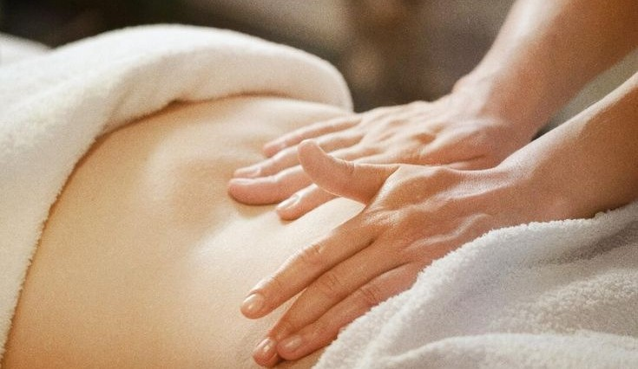
More than just slimming, this is a wellness therapy that helps you listen to your body, relax your mind, and renew your life energy every day.
Duration: 120 minutes/session

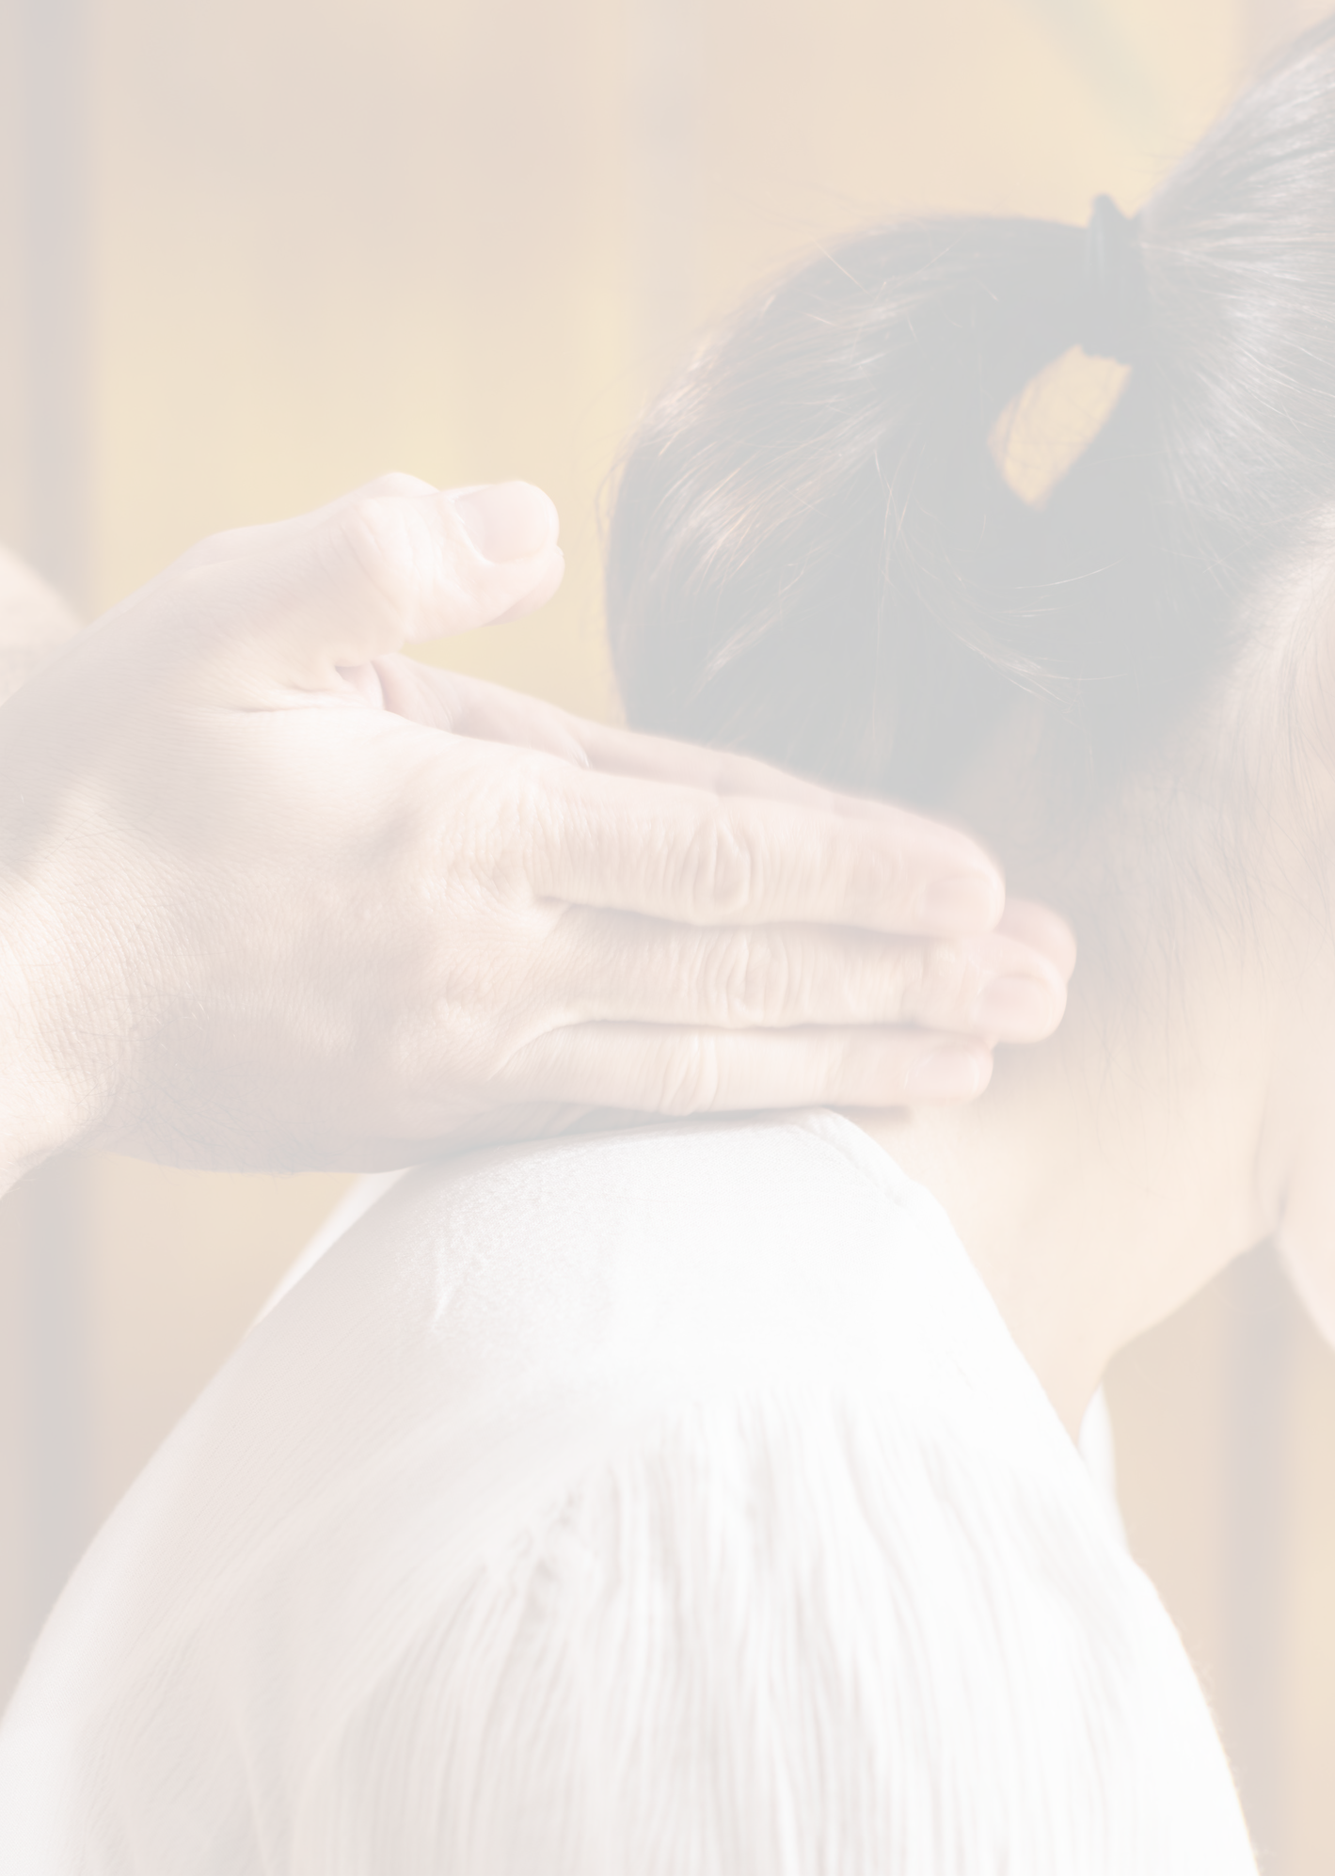

76
ONLINE SERVICES
In Person Services

Neck & Shoulder Massage (HNS)

30 Minutes
Location: HCM
The client will experience a neck-shoulder massage.

Duration: 30 minutes
Neck–shoulder massage is an extremely popular and effective body-care method, especially in modern life where people are constantly under work pressure, sit for long periods at computers, or use their phones continuously.

Standout benefits of neck-shoulder massage:

- Reduces stress and relaxes the whole body — Kneading and acupressure movements stimulate the nervous system and release endorphins, the "happiness hormone," helping you feel light, relaxed, and noticeably less stressed.

- Reduces neck/shoulder pain and muscle stiffness — Massage relaxes muscles and increases blood flow to the neck and shoulders, reducing the tension, soreness, and numbness commonly caused by long periods in one posture.

- Increases blood flow to the brain — The acupoints in the neck and shoulders are directly connected to blood flow to the head. Proper massage improves cerebral circulation, memory, and reduces headaches, dizziness, and fatigue.

- Improves sleep — Gentle neck-shoulder massage relaxes the nerves and balances the sympathetic nervous system, helping you fall asleep more easily and sleep more deeply.

- Helps regulate blood pressure and reduce chronic stress — Stimulating the correct acupoints not only reduces pain but also helps stabilize blood pressure, heart rate, and the central nervous system, bringing an overall sense of balance and relaxation.

- Improves posture and reduces the risk of early degeneration — Regular massage loosens the neck-shoulder-back muscles, reduces pressure on the cervical spine, and helps improve posture while preventing conditions such as cervical spondylosis, torticollis, and herniated discs.

- Activates the flow of energy in the body — From an energetic perspective (as in Reiki or wellness practices), the neck and shoulders are the connecting area between the head, mind, and body. When this area is relaxed, energy flows more freely, leaving the body feeling light, alert, and full of vitality.


77
ONLINE SERVICES
In Person Services

Neck & Shoulder Massage (HNS)

60 Minutes
Location: HCM
The client will experience a neck-shoulder massage.

Duration: 60 minutes
Neck–shoulder massage is an extremely popular and effective body-care method, especially in modern life where people are constantly under work pressure, sit for long periods at computers, or use their phones continuously.

Standout benefits of neck-shoulder massage:

- Reduces stress and relaxes the whole body — Kneading and acupressure movements stimulate the nervous system and release endorphins, the "happiness hormone," helping you feel light, relaxed, and noticeably less stressed.

- Reduces neck/shoulder pain and muscle stiffness — Massage relaxes muscles and increases blood flow to the neck and shoulders, reducing the tension, soreness, and numbness commonly caused by long periods in one posture.

- Increases blood flow to the brain — The acupoints in the neck and shoulders are directly connected to blood flow to the head. Proper massage improves cerebral circulation, memory, and reduces headaches, dizziness, and fatigue.

- Improves sleep — Gentle neck-shoulder massage relaxes the nerves and balances the sympathetic nervous system, helping you fall asleep more easily and sleep more deeply.

- Helps regulate blood pressure and reduce chronic stress — Stimulating the correct acupoints not only reduces pain but also helps stabilize blood pressure, heart rate, and the central nervous system, bringing an overall sense of balance and relaxation.

- Improves posture and reduces the risk of early degeneration — Regular massage loosens the neck-shoulder-back muscles, reduces pressure on the cervical spine, and helps improve posture while preventing conditions such as cervical spondylosis, torticollis, and herniated discs.

- Activates the flow of energy in the body — From an energetic perspective (as in Reiki or wellness practices), the neck and shoulders are the connecting area between the head, mind, and body. When this area is relaxed, energy flows more freely, leaving the body feeling light, alert, and full of vitality.

Foot Reflexology Massage
ONLINE SERVICES
78
In Person Services

Foot Reflex
Location: HCM
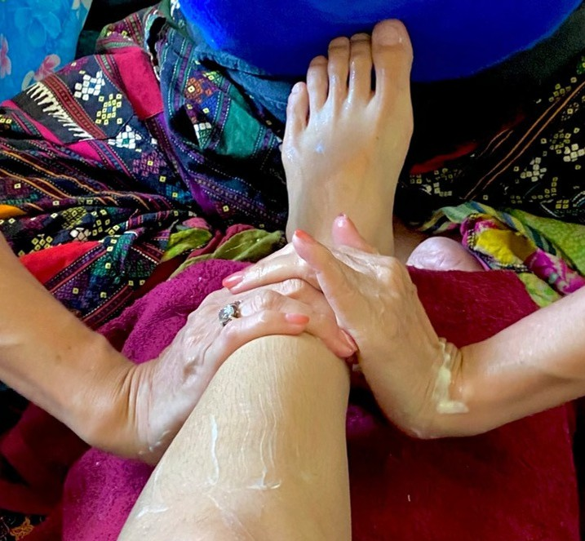
The client will experience foot acupressure/reflexology massage, a method of pressing acupoints that correspond to the body's internal organs, helping detoxify and improve organ health.
Duration: 60 minutes

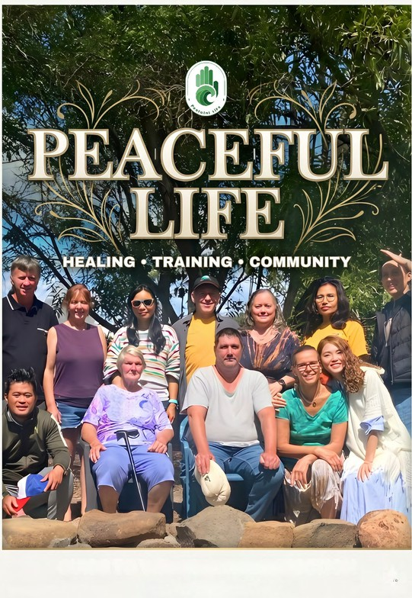
79

